The Body Keeps Its Own Clock
Lifespan, Minds, and Why Ten Thousand Years Is Not a Straight Line
Lothar J. Musiol

The Body Keeps Its Own Clock: Lifespan, Minds, and Why Ten Thousand Years Is Not a Straight Line
Copyright © 2026 Lothar J. Musiol. All rights reserved.
Look First, Volume 3.
Kindle edition.
No part of this book may be reproduced in any form without written permission from the author, except for brief quotations in reviews.

Contents
Prologue: The Capsule and the Hands
How to Read This Book
The Carrot, If You Start Here
A Note on the Series
Author’s Note
PART I — Many Clocks
1. Her Hands Still Age
2. Lifespan Is Not Healthspan
3. Many Clocks, Not One Fuse
4. Local Fixes
5. Not a Fountain
PART II — The Organ You Already Use
6. We Already Use the Organ
7. Cognitive Enhancement, Two Temperatures
8. The Carrot Has No Off-Switch
PART III — Not a Straight Line
9. The Last Fifty Years Were Not a Straight Line
10. S-Curves and Invoices
11. Ten Thousand Years Is Not ×200
12. Coordination, Wars, Institutions
PART IV — The Honest Body
13. Medicine’s Invoices
14. Adjusting Is Not Spare Capacity
15. Copies, Uploads, and Cold Immortality
16. The Honest Body
APPENDIX — The Scientific Detail
How to Read These Notes
A0 / A1. A Local Dose Is Not a Species Change
A2. Life Expectancy, HALE, and the Supercentenarian Tail
A3. Hallmarks, Hayflick, and Why One Switch Is Not on the Counter
A4. CRISPR-Class Edits: This Gene, This Tissue, This Invoice
A5. Cancer, Plumbing, Neurodegeneration: Many Doors
A6. The Ten-Percent Sentence, Lesions, and the Energy Bill
A7. Tools with Invoices: Sleep, Hearing, Stimulants, Implants
A8. Wanting, Liking, and Mismatch with More Calendar
A9. Vaccines, Packets, Sequence, Compute — and Named Walls
A10. Logistic Growth, Moore’s Bend, Sequencing’s Collapse
A11. Why 10,000 / 50 Is Arithmetic, Not a Method
A12. Meetings, Ledgers, Famines, Fronts
A13. Trials, Harm, and Who Pays for the Local Fix
A14. Plasticity Is Real and Expensive
A15. A File Is Not a Worldline
A16. Inventory of Claims, by Temperature
Equations at a Glance
Further Reading (tiered)
Glossary

Prologue: The Capsule and the Hands
A capsule arrives on the same delay as the orbiter’s voice. The label is optimistic. Her hands are not.
She works a greenhouse on a dead world — wet soil under LEDs the color of an overcast noon, a tray of basil that does not belong to this dirt, a radio that answers a quarter-hour late, or four minutes, depending on the week. There is no conversation. There is a stack of monologues that eventually, if everyone lives, amount to a plan.
The capsule is a local win in a blister pack. A joint that still works. A season she can still hit an airlock for. She takes the dose because local wins are the only kind biology has ever reliably sold. She does not become a different species. She names the basil, which is sentimental, and logs the pH, which is not.
This book is about what that scene is allowed to mean, and what a slide deck is not allowed to sell you on the back of it.
The short version, before it has been earned:
Lifespan is not healthspan. Aging is many clocks, not one fuse. A gene fix is a local repair — this instruction, this tissue, this invoice — not a fountain. The sentence we only use ten percent of our brain is false. You do not have a spare ninety percent in the cupboard waiting for a password. You have the organ you already use, plus sleep, plus practice, plus tools, plus other people. The carrot that makes a body chase a cue has no off-switch. A long life does not install one. And the last fifty years of real, uneven progress are not a method for drawing a straight line to the year 12,000.
Those are recognitions, not moods. They wear temperatures. The first chapter teaches the temperatures. The rest of the book spends them on mornings you would vote to repeat, on scissors with paperwork, on an energy bill the skull already pays, and on the walls that have names: energy, materials, attention, institutions, wars.
If you came for helium, you will not get helium. You may leave with a colder, better want: more mornings that are still worth logging.

How to Read This Book
Every claim in these pages wears one of three temperatures. The difference matters more than any slogan.
Hot — established. Measured, repeated, and used to predict new measurements. Lifespan and healthspan are different pots. The “ten percent of the brain” sentence is false. A sickle-cell-class gene edit can, in a growing list of cases, correct a broken instruction in a lineage of cells that will keep the correction. The last half-century produced real, uneven gains: vaccines that closed rooms of death, a genome you can read without a monastery, packets, cheaper compute.
Warm — working account. The best story we have, with real gaps. Aging is many clocks, not one fuse: the pieces are real; a single kitchen switch is not on the counter. Modest further gains in healthy years this century, in rich-country medicine, if institutions hold. Progress that is more often an S-curve than a ray. Whatever is invented will still pay energy, coordination, and the body’s invoices.
Cold — speculation dressed as a product. Allowed as a wish. Not selected by present levers. A body-wide rewind. A scheduled 150-year, 200-year, or thousand-year ape. Unlocking a hidden ninety percent of mind. Last fifty years × 200 = the furniture of the year 12,000. A file that is you, forever. A required last mind at the end of time. Progress as a law that fires if we wait.
A claim can change temperature. A local gene fix that was a paper in 2012 can be a clinic in 2023. A fountain does not get warmer because the local fix did. Do not let a hot win launder a cold catalog.
On a standing rule from the rest of this series: string theory, if it is named, cannot currently be tested. It is a large mathematical framework. It has not produced a unique, risky prediction that would kill it if the experiment came out otherwise. This book barely needs it. If a slide uses “quantum” as incense over a longevity claim, ask for the invoice, not the incense.
A few scenes are stories: a greenhouse on a dead planet, a radio that answers late, a capsule that may keep a joint useful, a committee that cannot agree, a founder with a straight line on a wall. They are thought experiments with dirt on them. The numbers in them are real. The people are invented. They are here so the clocks have somewhere to sit besides a diagram.
The main chapters keep the numbers in the sentence, the way a good explainer talks at a table. A handful of relations are important enough to sit still.
where HALE is healthy life expectancy — years you would, on present evidence, vote to repeat — not the years a wall clock can still be embarrassed by a pulse.
Those numbered marks, and the tables behind them, live in the Appendix. If you want the scaffolding, it is there. If you want the argument, you can finish the book without opening the back.
You do not need a medical degree. You do not need Book 1. You need curiosity and a willingness to let a miracle come apart into pots.

The Carrot, If You Start Here
Book 1 of this series taught a kitchen fact about wanting: a lineage that must copy, search, and pay will not last if the staff treats the invoice as optional. Pleasure is staffing. The cue can be turned up until a fake outbids the thing. The carrot has no off-switch labeled this is only a picture.
That book said it about a feast and a fake. You do not need those pages. The fact is still true if the feast is a long life.
A Pleistocene wanting-loop — seek, tag, chase, get a stamp, seek again — in a body that lasts 120 years is not a wise king. It is a mismatch with more calendar. Sugar, a slot, a feed that never ends, a slide that says enhancement: same family. Wanting is one juice. Liking is another. The off-switch was never hired. Look first before you call the extra years an upgrade. Chapter 8 teaches the loop in full. One courtesy is enough. The rest of this book will not assign Book 1 as homework.

A Note on the Series
This book is Volume 3 of Look First. It is a complete book. You are not being assigned homework.
If you already have Volume 1, The Universe Has No Now, you will recognize a woman, three temperatures, and a habit of looking first. You do not need its leftover glow, its courtroom about the first three minutes, or its map of other solvents. Those rooms stay there. This kitchen is the body, the organ you already use, and the lie of the straight line.
If you already have Volume 2, A Permit Is Not a City, you will recognize the same greenhouse and a ruder question about camps. This book does not reopen landing windows. A pill is not a downtown.
A backward point in these pages is a courtesy, not a chore. The loaf — the idea that all the times are already on the inventory — gets at most one sentence here. You can finish without it.
You can stop here. Her hands will still age tomorrow. That is not a tragedy the cosmos owes you a refund for. It is the starting fact.

Author’s Note
Most people meet the future of the body in the wrong order.
First comes a headline about a gene. Then a chart that goes up and to the right. Then a sentence that says we only use ten percent of the mind, so the other ninety is a tank. Then — if the talk has nerve — a straight line from the last fifty years of gadgets drawn across ten thousand years of furniture nobody can name. Time is treated as a fuse you can pull. DNA is treated as a fountain. The brain is treated as a cupboard. Civilization is treated as a transistor with a calendar.
That order is commercially understandable. It is roughly the order a slide deck discovers these things. It is not the order that makes the invoices easiest to see.
This book runs a different sequence on purpose. It starts with a pair of hands that still age after a useful dose, because that is what a local win looks like when you refuse helium. Only after lifespan and healthspan have been split into two pots does it turn to the many clocks, the local scissors, the organ you already staff, the carrot that will not switch off, and the cartoon that multiplies a real half-century by two hundred and calls the product a kitchen.
John D. Barrow’s short books are still the formal model: brief chapters, no swagger, a clean line between a measurement and an idea for ideas. The biology neighbors are the honest histories — the gene as a local object, medicine as an S-curve, the brain as an energy bill — not the startup keynote. Where a clinic and a keynote disagree, the disagreement is the point.
A book like this should not succeed because a reader can recite a hallmark of aging. It should succeed if a sequence of recognitions arrives and stays:
that years on a wall clock are not years you would vote to repeat;
that aging is many clocks, and a shout at one does not reset the kitchen;
that a gene fix is this tissue, this invoice — a class of win, not a fountain;
that a 150-year scheduled product is a wish, and a thousand-year ape is colder still;
that the ten-percent sentence is false, and idle-looking tissue is still on duty;
that plasticity is real and expensive, not a spare tank;
that education, sleep, a hearing aid, a stimulant with a known bill are tools, not unlocks;
that the carrot has no off-switch, and a longer life is more calendar for the mismatch;
that the last fifty years were real and are not a method;
that progress is more often an S-curve, and diminishing returns are a kitchen fact;
that fifty into ten thousand is two hundred, which is arithmetic, not physics;
that the limit is often a meeting, a ledger, a famine, a front;
that a file is not a worldline;
and that the honest product, if you want one, is a morning still worth hitting an airlock for.
That last recognition is not a counsel of despair. It is the opposite. If helium is not scheduled, meaning is made in the useful season — this copy, this joint, this pH.
Readers of The Universe Has No Now will notice a family resemblance: start with the variable that makes the hygiene simple, not the variable that got sold first. There, the variable was the event. Here, it is the clock the body actually keeps — many of them — and the difference between a local fix and a sermon.

PART I — Many Clocks

1. Her Hands Still Age
The airlock sticks on cold mornings. She hits it with the heel of her glove, the way you hit a jammed kitchen drawer, and it sighs. Inside, the greenhouse is the only room that smells like a lie: wet soil, torn basil, a sweetness that does not belong to this planet. The lie is maintained with LEDs and a tray of water she melted, yesterday, from a vein of ice the color of dirty chalk.
A capsule arrives on the same delay as the orbiter’s voice. Twenty minutes, or four, depending on the week. The label is optimistic. A small paragraph about support and maintenance and a season that can still be used. Her hands are not optimistic. The knuckles have begun to look like a map of a place she has already walked. The joint that used to open a jar without a thought now asks for a meeting.
She takes the dose because a joint that still works is a local win, and local wins are the only kind biology has ever reliably sold. She does not become a different species. She names the basil, which is sentimental, and logs the pH, which is not. On a dead world, sentiment is allowed as long as it does not get to vote.
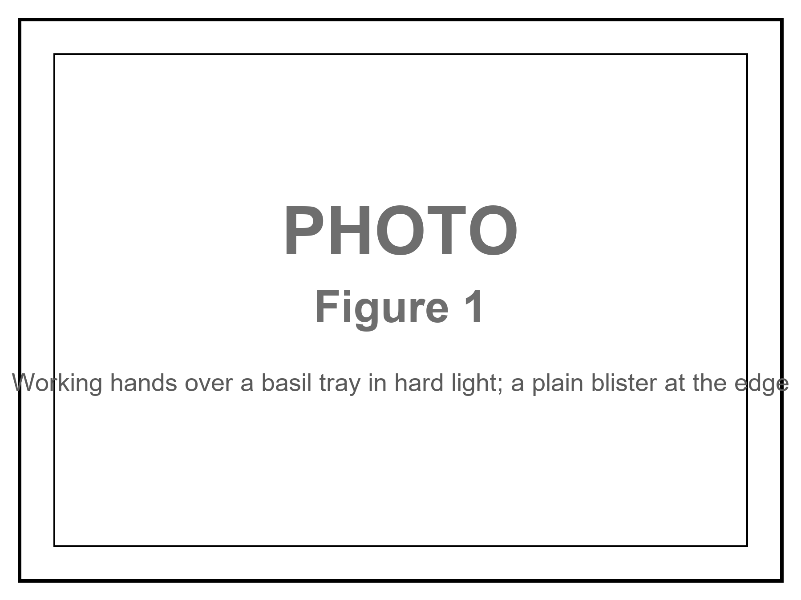
Figure 1. Working hands over a basil tray in hard light; a plain blister at the edge. The dose is local. The hands are still the hands.
This is the only honest picture of “the future of us” this book will allow in the near term. Not a downtown on a poster. Not a thousand-year ape with a product number. A body you can weigh. A chemistry you can bully. A radio that is late on purpose. A useful season, if the invoice clears.
The rest of the book is about what that scene is not allowed to launder.
People meet a capsule and promote it.
The promotion has a few favorite costumes. The dose becomes a species change. The gene becomes a fountain. The brain becomes a cupboard with ninety percent still in the wrapping. The last fifty years of gadgets become a ruler you can lay across ten thousand years of unnamed furniture. Each costume is useful to someone who sells keys. None of them is a measurement.
This book will keep a kitchen habit about claims. Every sentence that matters wears a temperature.
Hot means established: measured, repeated, used to predict the next measurement. Her hands age. That is hot. A pulse can embarrass a wall clock for a long evening in a chair, and those extra years are not the same pot as years you would vote to repeat. That split is hot. The sentence we only use ten percent of our brain is false. That correction is hot. In a growing list of cases, a broken instruction in a lineage of cells can be reached and corrected, and the lineage keeps the correction. That class of win is hot.
Warm means a working account with real gaps. Aging is many clocks, not one fuse. The clocks have names and papers. A single switch that resets the kitchen is not on the counter. Modest further gains in healthy years this century, in rich-country medicine, if the institutions that run trials and pay invoices still exist. Progress that rises, drunk, and then meets a wall more often than it rises forever. Whatever is invented will still pay energy, coordination, and the body’s bills.
Cold means a wish allowed by talk, not selected by present levers. A body-wide rewind. A scheduled product at 150 years, or 200, or 1,000. Unlocking a hidden full brain. Last fifty × 200 = the year 12,000’s kitchen. A file that is you, running forever. A required last mind at the end of time. Progress as a law that fires if we wait.
A claim can change temperature. A local edit that was a clever paper can become a clinic. A fountain does not become a clinic because the local edit did. The laundering is the sport this book is here to spoil.
If you have Volume 1 of this series, you have already met the temperatures on a different kitchen clock — the one that pretended the universe shared a now. You do not need those pages. The hygiene travels. The leftover glow does not. We will not reopen that courtroom.
If you have never met the temperatures, you have them now. Use them on the capsule. Use them on the slide. Use them on the sentence that says DNA as if DNA were a tap.
She is an invented person. The numbers around her are not invented.
A human joint is cartilage, bone, a little sac of fluid, a staff of cells that keep a surface honest. The staff gets worse at the job. Inflammation writes graffiti. The surface pits. Pain is not a metaphor. Pain is a measurement the nervous system makes and will not stop making because a label was optimistic. A drug that lowers the graffiti, or a lubricant the body will accept, or a replacement that a surgeon can bolt in, is a local win. Local is the word that has to sit still.
where local means this tissue, this season, this invoice — not a reset of the house.
The same woman still copies DNA with a small error rate. She still shortens the little caps on the ends of chromosomes in the lineages that divide. She still runs mitochondria that leak and forget. She still keeps an immune system that has learned too many grudges and forgotten some of its tact. She still accumulates cells that refuse to die and then spoil the room. She still wears grooves in a brain that has been on duty since the first language she learned. Chapter 3 is those clocks. Chapter 1 is the refusal to let one useful dose pretend it wound them all back.
Look first.
That rule, in Volume 1, meant do not plague a dark sea because you were lonely for a cousin. Here it means a narrower, ruder thing: do not overwrite a genome, or a childhood, or a morning you already know how to staff, because a slide said enhancement. The slide is a cue. The carrot that makes a cue feel like a feast has no off-switch. Chapter 8 teaches the loop. You do not need a prior book to take the warning. If a capsule arrives with a sermon attached — this is the first day of the new species — put the sermon down and keep the joint, if the joint is what you paid for.
She logs the pH because the dirt has a chemistry, and the chemistry can be bullied, and bullying is a measurement. Sentiment names the basil. Sentiment does not get to vote on whether the tray is too alkaline. The future of the body is the same kitchen. You can name the hope. You log the clocks.
A word about helium, so we do not waste it later.
Helium, in this series, is the thing a slide wants you to treat as already on the loading dock: immortality, a downtown on a dead world as a product this decade, a required mind at the end of time, a spare brain in the cupboard, a straight line to furniture we cannot name. Helium is cold when it is sold as scheduled. Useful seasons are not helium. A hearing aid is not helium. A vaccine that closed a room of death is not helium. A sickle-cell-class edit that lets a person walk without a crisis is not helium. Those are tools. Tools have invoices. Helium is what you wait for instead of hitting the airlock.
She does not wait for helium. She hits the airlock. The rest of this book is the argument that this is not small-mindedness. It is the only size biology has ever reliably sold.
Appendix A1 writes what “local” has to mean when a pharmacist and a marketer share a noun. Here, keep the hands. They still age. That is the first hot fact. Everything colder will have to walk past it.

2. Lifespan Is Not Healthspan
Lifespan is not healthspan.
Lifespan is how long the clock on the wall can be embarrassed by your pulse. Healthspan is how many of those years you would vote to repeat. You can add frail years. That is easy to mistake for a miracle. It is a longer evening in a chair. The honest product, if you want one, is mornings that are still worth hitting an airlock for.
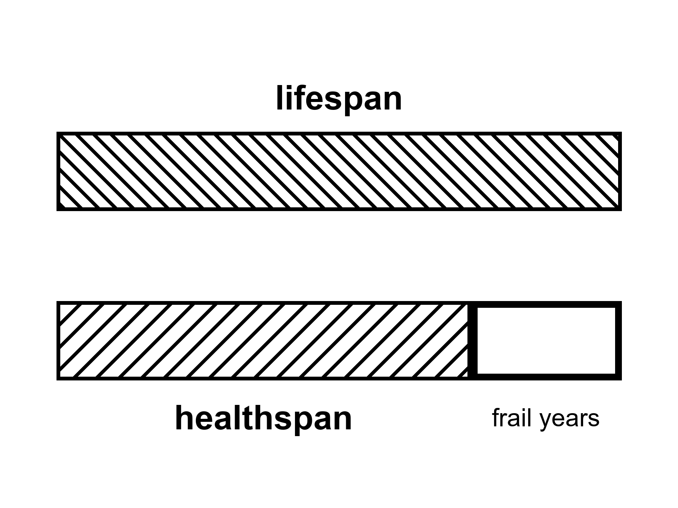
Figure 2. Two full-width bars: lifespan and healthspan. The leftover hatch is frail years. Notice which bar people think they bought.
The split is hot. Demographers have been running it for decades under plainer names. Life expectancy at birth is a summary of death rates in a year, not a promise to a baby. Healthy life expectancy — HALE, in the World Health Organization’s ledger — subtracts years lived with disability, weighted by how much function was lost. The subtraction is ugly and necessary. A country can raise the first number by keeping people alive in a bed. The second number tells you whether the extra was a morning.
where HALE is the years lived in a state you would, on present evidence, vote to repeat.
In rich countries the wall-clock number sits in the low-to-mid eighties for women, a little lower for men. Japan, Switzerland, Spain, Australia, Italy, the Nordic kitchens: that band. The United States runs lower — the high seventies in recent ledgers, after a ugly dip and a partial climb — because a rich country can still fail at the boring work: guns, opioids, metabolic disease, a medical bill that is also a maze. Global life expectancy rose by decades across the twentieth century. Most of that rise was not a fountain. It was clean water, vaccines, antibiotics, midwifery, food that arrived. Child death is a slaughter of years. Stop the slaughter and the average leaps. That leap is hot, and it is mostly finished in the places that already have pipes.
Healthspan lags. The lag is the point. A person can live into the eighties and spend the last eight or ten years in a narrowing of the room: the walk that became a shuffle, the names that need a prompt, the joint that will not take the airlock, the breath that makes a sentence a project. Those years count on the wall. They do not automatically count as the product people heard when they heard we are living longer.
Compression of morbidity is the warm hope with a name. You keep the bad years short and stacked against the end. Expansion of morbidity is the easy mistake: you stretch the bad years because you are good at not letting the pulse stop and less good at keeping the morning. Both happen. Different diseases, different countries, different decades. The honest ledger is not a vibe. It is two numbers and a fight about the weights.
Jeanne Calment died at 122.
That sentence is a tail, not a product. She was a French woman with a documented life that ran from 1875 to 1997, and the documentation has been picked at, as tails always are. Take the number as ~122 and sit it still. It is the far end of a distribution, not a mean you can schedule. Supercentenarians — 110 and over — are rare enough to be a sport for validators. The sport is not a clinic. Nobody has a protocol that prints 122. Nobody has a protocol that prints 150 as a SKU. The tail says a human body can, under a lottery of genes, luck, and a century that did not kill her early, run that long. The tail does not say your slide can order the lottery.
Maximum lifespan and life expectancy are different pots again. Life expectancy is a population average that moves when children stop dying and when seventy-year-olds stop dying of things we learned to treat. Maximum lifespan is the right-hand fence of the species as observed. The fence has not sprinted. The averages did. That is why a chart of “we doubled life” can be true about the average and a liar about the fence. We doubled the average mostly by not losing the young. We did not double Jeanne Calment.
A person who wants helium hears 122 and adds a gene. The arithmetic feels like science because both sides have numbers. It is not a method. Chapter 5 is the cold water. Here, keep the two pots. You can raise a mean without moving a fence. You can move a fence in a mouse and not in a woman. You can add years to a pulse and subtract them from a vote.
What would a vote even mean?
Not a survey in a mall. A vote, in this book, is the test you already know how to run. Would you take this Tuesday again? The Tuesday with the walk, the work, the name of the basil, the radio that is late, the pain that is a two and not an eight. If the answer is yes, that year is healthspan even if a doctor’s form has a code on it. If the answer is no, and the no is not a mood but a room that has closed, that year is lifespan without the product.
People lie to themselves about the vote. A slide can make a chair look like a morning. Grief can make a morning look like a chair. The scientific point is narrower than therapy. When a company says years of life, ask which pot. When a government boasts a rising expectancy, ask what happened to HALE. When a founder says 150 is conservative, ask for the fence, the species, and the invoice.
Rich-country medicine in the last seventy years added a great deal of lifespan and a real, smaller deal of healthspan. Hip replacements, cataracts, blood pressure pills, statins, HIV turned from a cliff into a condition, some cancers turned from a sentence into a long negotiation. Those are hot as classes of win. They are also a demonstration of the split. You can walk on a metal hip and still be running many clocks. You can see the basil again and still be tired in a way sleep does not fix. The product was the walk and the sight. The sermon was we are becoming immortal. The sermon was cold.
Modest further gains in healthy years this century, in the kitchens that already have pipes and trials, are warm. Not a law. A continuation of a slowing curve if the institutions hold. Everyone on Earth shares those gains: cold as a default. The invoices are unequally paid. Chapter 13 is that inequality with the lights on. Here, notice that a global average can rise while a neighborhood falls, and that a neighborhood can rise while a body in it is still a chair.
She would vote for a morning that includes the airlock. She would not vote for a longer evening in which the radio still answers and the hands will not. The capsule, if it works, buys the morning. That is already a great deal. It is not a different species. It is not a fence moved to 200. It is a joint.
Appendix A2 writes the ledgers: life expectancy bands, HALE gaps, Calment as a tail, the United States as a rich-country warning. Here, keep the two bars. If you remember one sentence from this chapter, make it the title. Lifespan is not healthspan. The rest of the book is what happens when people sell you the first and bill you as if you bought the second.

3. Many Clocks, Not One Fuse
Aging is not one fuse. It is many clocks.
That sentence is hot-to-warm. Hot as a refusal of the single-switch story. Warm as a map of mechanisms that are real, incomplete, and still being argued by people who do this for a living. The map is not a product. The map is why a pill that shouts at one clock does not reset the kitchen.
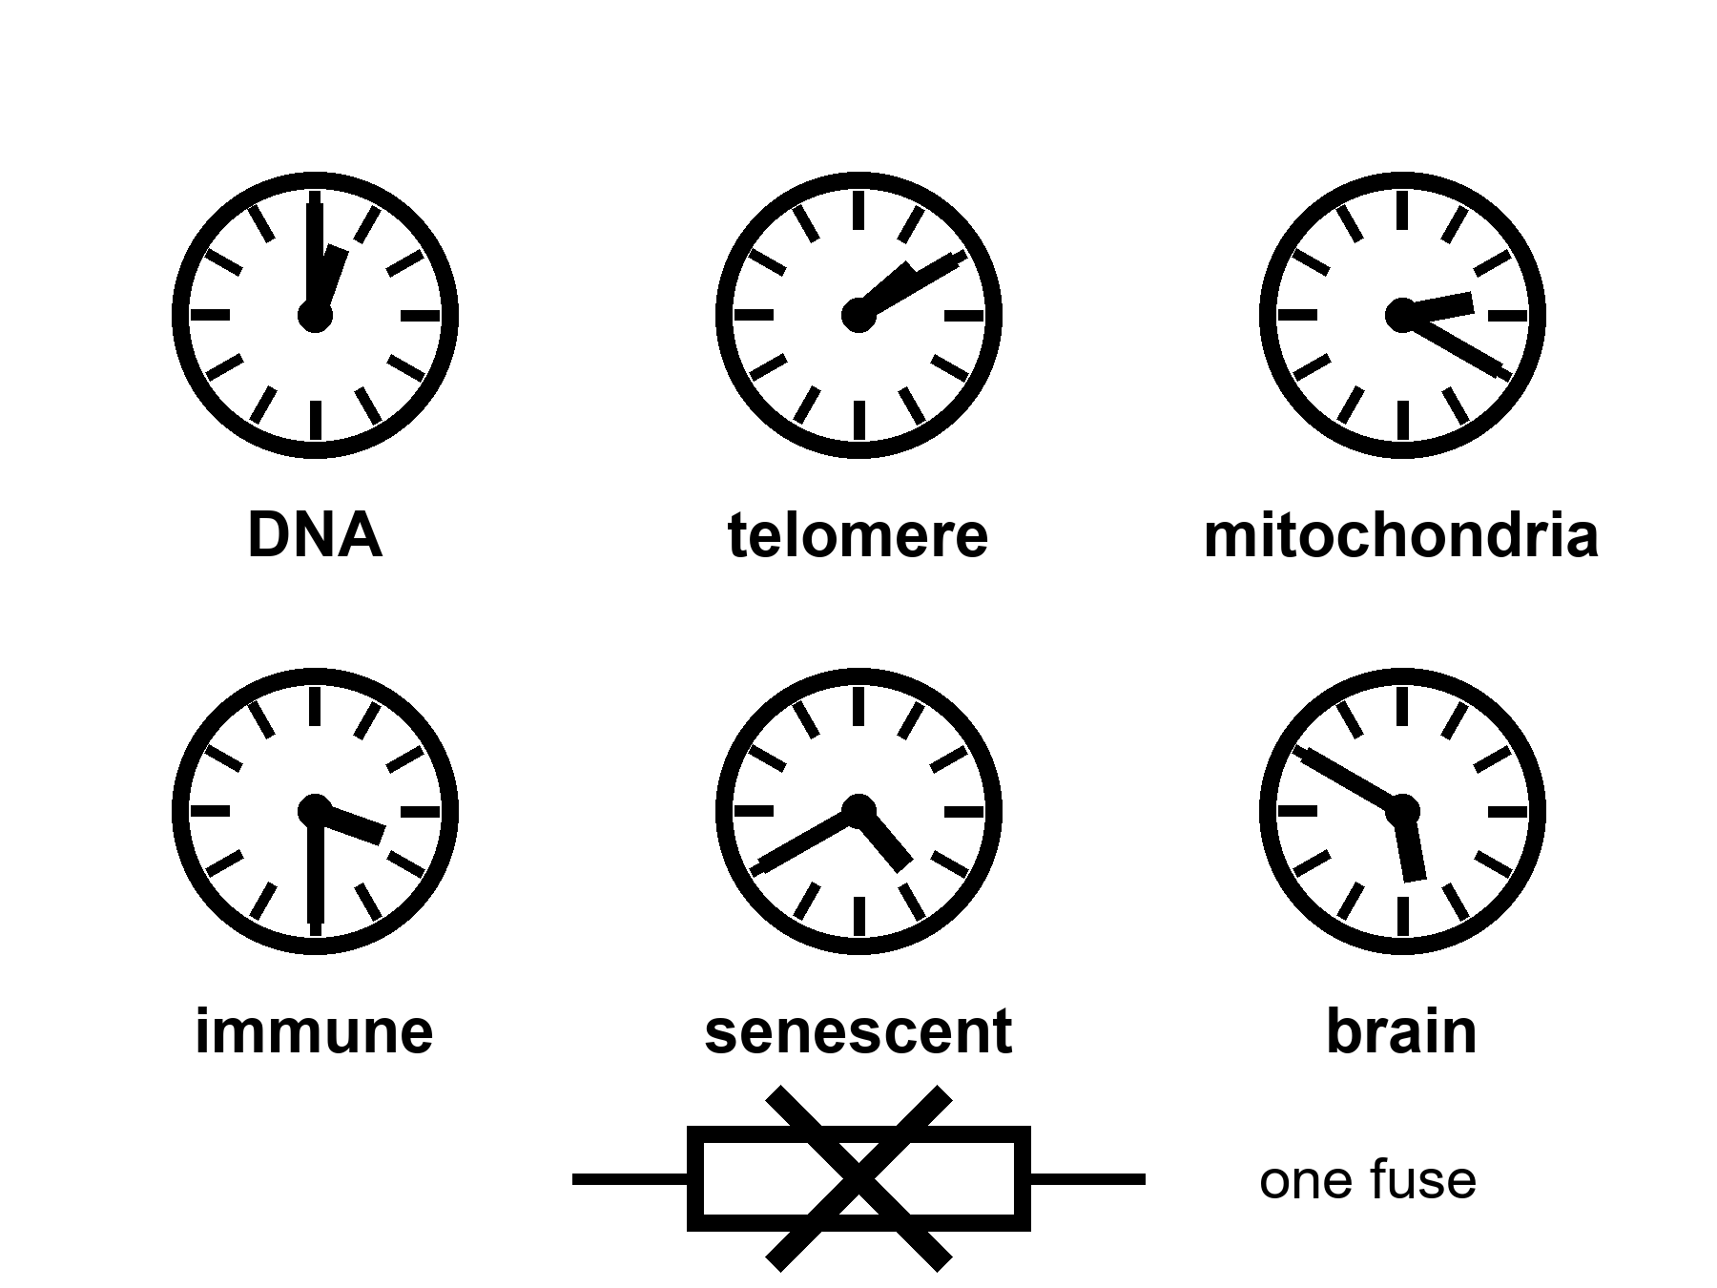
Figure 3. Six kitchen clocks, one fuse crossed out. DNA, telomere, mitochondria, immune, senescent, brain. A shout at one is not a rewind.
Start with the letters.
DNA is a chemical that copies. Copying has a residual error rate even when the staff is sober. Ultraviolet light, oxidation, a replication fork that stalls, a repair crew that arrives late or guesses: the book acquires typos. Most typos in a cell that will die next week do not matter. Typos in a stem cell, or in a lineage that keeps dividing, can matter a great deal. Cancer is one way a typo becomes a career. Loss of function is another. Genomic instability is the grown-up name. It is a clock because damage accumulates and the repair budget is not infinite. It is not the clock. People with unusually clean repair can still go gray, go stiff, go slow. People with a broken repair gene can get a specific cancer young and still not explain why a heart stiffens at seventy.
Telomeres are the plastic tips on the shoelace.
Each time a linear chromosome copies, the very end is an awkward job. The cap shortens. An enzyme, telomerase, can pay the cap back. Most of your somatic cells do not run that enzyme as a lifestyle. A limit appears.
where the Hayflick limit is the observation that many human cell types in a dish divide about forty to sixty times and then stop.
Hayflick is not a mystic number. It is a dish fact with a molecular accent: short caps, a DNA-damage alarm, a cell that refuses to copy. In a body the story is messier. Stem cells have more telomerase. Cancers often steal the enzyme and become rude. A mouse is not a woman; mice have longer telomeres and shorter lives, which is already a warning against a single-clock sermon. Lengthening telomeres in the wrong cell is a cancer dare. Short telomeres in the right cell are a worn joint. The clock is real. The rewind is not a free lunch.
Mitochondria forget their job.
They are the old bacterial hires that make the majority of a cell’s ATP and leak reactive oxygen as a side effect of being a furnace. Their own small genome sits next to the furnace, which is a staffing error evolution never quite filed. Damage, deletion, a cell that becomes a mosaic of good and bad power plants: tissues that spend energy — brain, heart, muscle — feel it first. Mitochondrial disease in the young is a specific tragedy. Mitochondrial decline in the old is a background weather. A pill that makes mitochondria “happier” in a worm is a paper. A pill that resets a seventy-year-old woman’s furnaces without touching the rest of the house has not clocked in as a scheduled product. Warm as a target. Cold as helium.
The immune system grows bitter.
It learns. Learning is the point of adaptive immunity. Learning also means a repertoire that fills with old grudges — viruses you met in childhood, a cytomegalovirus that never quite leaves, a library of memory cells that occupy seats a naive cell might have used for a new flu. The innate side gets louder and sloppier: a background inflammation with a nickname, inflammaging, that is rude to vessels, to joints, to brains. Vaccines work less well in the old because the staff is tired and the library is crowded. That is a clock. It is why a flu shot is a tool and not a sermon. It is why “rejuvenate the immune system” is a research program and not a SKU.
Senescent cells refuse to die and then spoil the room.
A cell that has taken too much damage, or hit a telomere alarm, or been shoved by an oncogene, can enter a state where it does not divide and does not leave. It secretes a cocktail — the SASP, if you like letters — that tells neighbors to inflame, remodel, and sometimes misbehave. In a young tissue a few of these cells are a cleanup crew. In an old tissue they are squatters. Senolytics are drugs that try to evict them. In mice, evictions have made pretty graphs. In people, the graphs are early, mixed, and not a fountain. A senescent cell is one clock. Clearing some of them is a local experiment. The house still has the other clocks.
The brain wears its own grooves.
Neurons are mostly not a renewing lawn. They are a long-staffed office. They accumulate waste proteins that clump. They lose the tact of synapses. White-matter cables thin. Blood vessels stiffen and sprinkle silent insults. Sleep, which is when a good deal of the cleanup is supposed to run, fragments. The skull’s immune cells, the microglia, get their own bitterness. Alzheimer’s is not “aging.” It is a disease with aging as a steep risk factor and with its own ugly, plural mechanisms. Ordinary slowing — the name on the tip of the tongue, the night driving that became a negotiation — is another clock, overlapping, not identical. Chapter 6 will refuse the idea that this office was ninety percent empty. Here, notice that a brain clock can ruin a healthspan while a pulse is still embarrassing a wall.
Those six are not a complete inventory. They are a kitchen tour.
Researchers who try to be complete publish hallmarks: a list that began as nine and grew to twelve when the papers needed more drawers. Genomic instability, telomere attrition, epigenetic marks that drift, proteins that misfold and are not cleared, nutrient-sensing that forgets the difference between feast and famine, mitochondria, senescence, stem cells that exhaust, communication between cells that turns into gossip, autophagy that slacks, chronic inflammation, a gut ecology that goes off. Appendix A3 writes the list the way a review writes it. Here, the list is a warning. A list of twelve is already a confession that there is not one fuse.
Epigenetics deserves a sentence because it has become a product costume. Marks on DNA and its packaging change with age in ways you can train a clock to read. The clock is a predictor. It is hot as a correlate. It is warm as a mechanism. It is cold as a proof that wiping the marks wipes the person back to twenty. A predictor is not a fuse. You can have a gray hair and a young epigenetic score, or the reverse. You can reset marks in a dish and still have the same mitochondria, the same senescent neighbors, the same skull.
Nutrient sensing is the other costume. Calorie restriction lengthens life in some species and makes a miserable kitchen in others. Rapamycin, metformin, a fasting ritual: each has a paper trail. Some of the trail is real. None of the trail is a species change. A worm is not a woman. A mouse is not a woman. A thin, closely watched monkey is not a woman in a suburb with a night shift. The warm claim is that metabolism and aging talk. The cold claim is that we have the talking stick.
Why do people want one fuse?
Because one fuse is a product. Many clocks are a clinic, a budget, a set of local wins, a refusal. A slide that says aging is a disease is doing two jobs at once. One job is useful: it asks insurers and agencies to treat function as a target, not as fate. The other job is a laundering: if aging is one disease, it might have one drug. The second job is not selected by the hallmarks. The hallmarks selected a messy kitchen.
A filter, not a craftsman. Bodies that lasted long enough to copy were bodies that spent the repair budget on the reproductive years and not on an infinite warranty. There is no committee that chose seventy as a moral. There is a mesh that did not pay for a 200-year ape because a 200-year ape was not the cheaper way to get the next copy. That is not a purpose. It is why a fountain would have to fight a staffing decision that is older than agriculture.
She can take a capsule that helps a joint and still be running the other clocks. The basil does not care. The pH log does not care. A shout at telomeres does not rewind the immune grudges. A clearance of senescent cells in a knee does not unclump a protein in a hippocampus. This is not pessimism. It is the reason local wins are worth taking and sermons are worth putting down.
Appendix A3 writes Hayflick’s range, the hallmark table, the mouse-to-human translation problem. Here, keep the six clocks and the crossed-out fuse. If a founder shows you one knob, ask which five they left in the drawer.

4. Local Fixes
Gene fixes are local. That sentence should be printed on every slide that says DNA as if DNA were a fountain.
Hot: we can, in a growing list of cases, reach into a lineage of cells and correct a broken instruction — a blood disease, a rare enzyme, a tissue that will take the edit and keep it. CRISPR and its cousins are tools. They are not magic. They are scissors with paperwork.
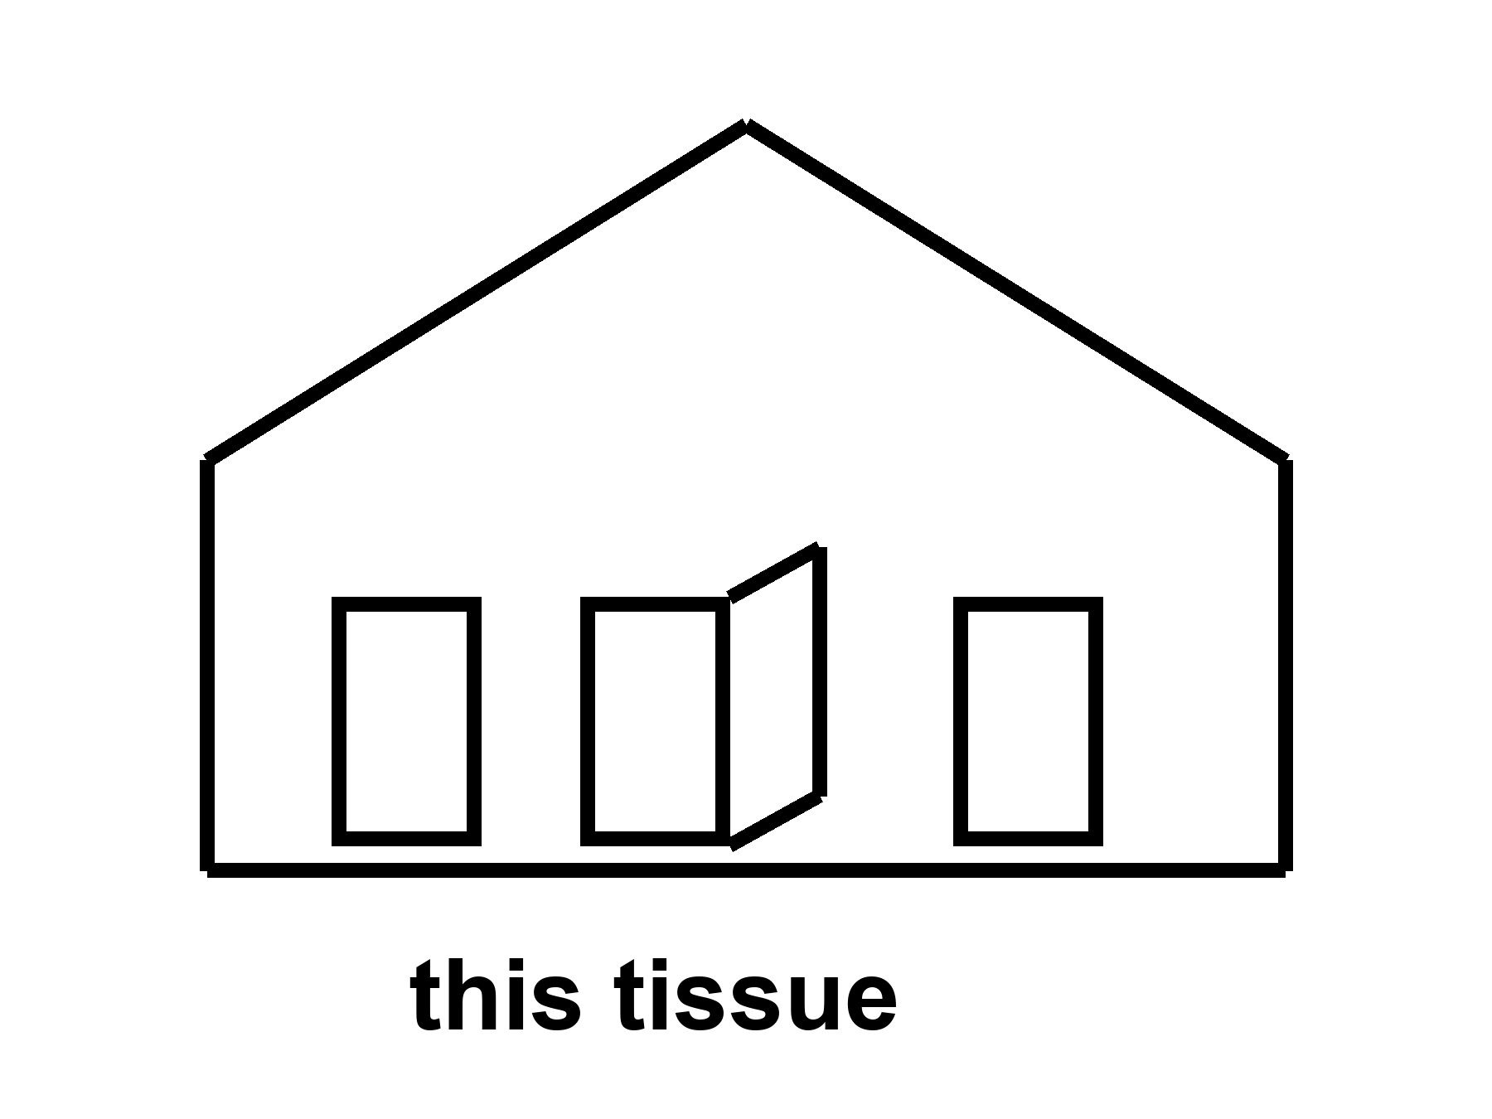
Figure 4. One door unstuck in a simple house. The label is this tissue. Scissors with paperwork, not a fountain.
Start with the scissors, because the brand names will rot and the class will not.
A genome is a long string. A disease can be a single wrong letter, a missing chunk, a control switch stuck in the wrong position. For a long time the only way to change that string in a person was luck: a bone-marrow transplant from someone whose string was kinder, a virus we did not design well, a prayer. Gene therapy, as a field, spent decades in the wilderness of immune reactions and leukemia scares and invoices that could bankrupt a kingdom. Then the scissors got sharper.
CRISPR, in the kitchen, is a bacterial memory system hired as a cutter. You supply a guide that finds a sequence. You supply an enzyme that cuts. The cell’s own repair crew then either wrecks the site (sometimes that is the point) or, with more paperwork, inserts a template. Base editors and prime editors are cousins that try to rewrite a letter with less of a cut. Viral vectors — AAV, lentivirus — are delivery trucks. Delivery is most of the problem. A truck that reaches the liver is not a truck that reaches the brain. A truck the immune system remembers is a truck you may not send twice.
where a local fix means this gene, in this tissue, in this person, at this price, with this known damage as the entry fee.
The sickle-cell-class win is the one that should be taught in every school that already teaches Mendel.
Sickle cell disease is a single-letter change in the adult hemoglobin gene. The wrong letter makes a protein that can stack, and the stack makes a red cell into a blade, and the blade jams vessels and wrecks childhoods. The heterozygote — one copy — is a malaria bargain the mesh kept. The homozygote is a chronic emergency. For decades the local fix was a matched donor’s marrow, if you had a match and a center and a body that could survive the conditioning. Now there is a class of autologous edits: take the person’s own blood-forming stem cells, edit them outside the body, wipe the old marrow with chemotherapy hard enough that the edited cells can take the seats, put the edited cells back.
One version of the class does not even correct the original letter. It wakes fetal hemoglobin, the version you used before you were born, by breaking a switch (BCL11A and its enhancer) that had turned the fetal gene off. The fetal protein dilutes the sickle protein. The crises fall. That is a local fix with a long invoice: manufacturing, a hospital stay, a conditioning regimen that is not a vitamin, a price that, in present ledgers, sits in the low millions of dollars per person. It is still a win. It is hot as a class. It is not a fountain. The person’s telomeres did not rewind. Their arteries did not become twenty. Their brain did not unlock a cupboard. Their children, if the edit was only in blood, still inherit the letter unless a different, ruder conversation is had about germline work.
Name the class, not a halo. Exagamglogene-class CRISPR for sickle cell and transfusion-dependent beta thalassemia is a 2023-era clinic fact. Lentiviral gene-addition cousins sit in the same drawer. The brand on the box will change. The structure will not: this lineage, this instruction, this bill.
Rare enzymes are the other honest drawer.
A child missing one metabolic enzyme can be a tragedy that a protein infusion, or a gene truck to the liver, or an edit in the right cells, can interrupt. Spinal muscular atrophy, a handful of immunodeficiencies, a retinal disease that steals a childhood’s sight: each has a story in which a local delivery changed a life. Each story has a graveyard next to it — the trials that triggered immune storms, the doses that did not reach the tissue, the prices that made a cure a rumor for everyone who did not live near the right zip code. Chapter 13 is the graveyard and the zip code. Here, keep the structure. A rare, monogenic, accessible tissue is the kind of lock these scissors were forged for. Aging is not that lock. Aging is the house.
Cancer, ironically, is already a gene-therapy customer and still not a fountain. CAR-T cells are a local rewrite of an immune cell to hunt a blood cancer. The rewrite can save a life and still leave the person aged by chemotherapy, aged by cytokine storms, aged by the clocks that were never the target. Solid tumors are ruder. A thousand-year ape would still need a cancer policy. Chapter 5 is that policy.
Germline editing — changing the string in a sperm, an egg, or a first clump of cells so that every tissue and every descendant carries the change — is a different door. It is technically closer than it was. It is ethically and politically a front, not a kitchen gadget. A front is Chapter 12’s kind of wall. This book will not print a catalog of designer children. Look first. A slide that says enhancement about a child who cannot consent is the carrot with a new face. The off-switch was not hired.
What CRISPR is not.
It is not a search-and-replace for “old.” Old is not a sequence. Old is the many clocks. You can imagine, cold, a future in which many tissues are edited, many times, for many letters, at a price a village can pay, with delivery trucks that know the brain and the heart and the stem-cell niches. You can imagine it. Imagination is not a schedule. The present kitchen is: a short list of monogenic wins, a longer list of trials, a delivery problem, an immune memory, an invoice, and a house that still ages while you celebrate the one door you unstuck.
She will not get a CRISPR for being fifty-eight and having hands. She might, in a later decade, get a better joint drug, or a better way to quiet a senescent crowd in a knee, or nothing new except the same bullying of chemistry she already knows. The capsule on the radio delay is honest if it stays local. It becomes a lie when the label starts talking about the species.
Appendix A4 writes the sickle-cell-class schematic, the delivery problem, and why “CRISPR” in a headline is not a method for helium. Here, print the sentence again. Gene fixes are local. Keep it.

5. Not a Fountain
A local fix is not a reset of every clock.
That is the laundering this chapter exists to stop. Chapter 4 gave you a hot win. This chapter will not take the win away. It will refuse to let the win rent a halo.
Cold: a body-wide rewind. A thousand-year ape as a scheduled product. Helium. The rest of the house still ages while you celebrate the one door you unstuck. Cancer is not one door. The brain’s long goodbye is not one door. Atherosclerosis is a plumbing problem with a biological accent. Local is the word. Keep it.
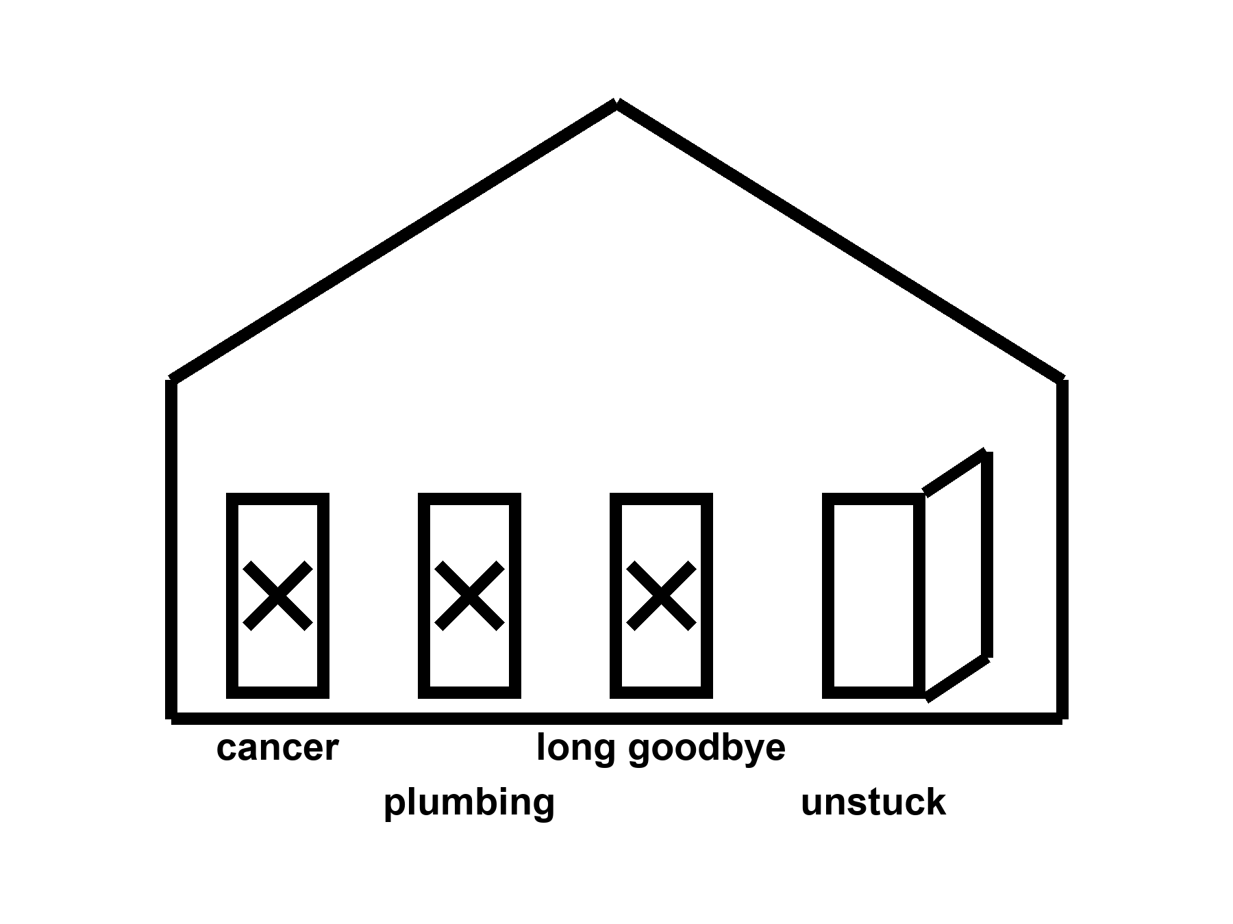
Figure 5. The same house. Three doors still stuck: cancer, plumbing, long goodbye. One unstuck door is not a remodel.
Cancer is not one door.
Cancer is hundreds of careers a cell can take when the copy-edits and the brakes and the immune surveillance fail in combination. A blood lineage you can harvest and rewrite is one kind of fight. A pancreas, a lung, a glioblastoma behind a barrier that keeps trucks out, a metastasis that has already rented rooms in bone: other fights. Prevention — do not smoke, vaccinate against the viruses that set up shop, find the polyp while it is a polyp — is still the cheap, rude, hot work. Treatment has become, in some cancers, a long negotiation with targeted drugs and immune checkpoint tricks and local rewrites. Five-year survival moved for some diagnoses and barely moved for others. Curing one blood cancer in a twenty-year-old does not make her immortal. It makes her a person who will now have to die of something else, later, which is exactly the point of medicine and exactly not a fountain.
A body that lasted 200 years would be a longer exposure to the same mutational weather. More copies, more chances, more careers for a rude cell. Unless you imagine a surveillance state inside every tissue that never sleeps and never errs — cold, as a scheduled product — the long ape is a cancer problem with more calendar. The mesh did not have to solve that problem. A product that claims to have solved aging without a cancer policy has not read the house.
Atherosclerosis is plumbing with a biological accent.
Fat, calcium, immune grudges, a lining that scars, a clot that finishes the job: the pipes of the heart and brain. Blood-pressure pills, statins, smoking cessation, a stent, a bypass — local, incremental, hot as classes of win. They moved rich-country death. They did not make arteries into a twenty-year-old’s pipes on demand. A gene that lowers an ugly lipoprotein can be a local fix for a family that inherited a disaster. It is not a rewind of seventy years of shear stress and dinner. The long ape would still have fluid dynamics. Fluid dynamics does not care that your slide is exponential.
The brain’s long goodbye is not one door.
Alzheimer’s, Parkinson’s, Lewy bodies, vascular scraps, frontotemporal ruin, the ordinary narrowing that is not a named disease and still steals the vote: plural. Amyloid is a character in one of the plays and not the whole theater. A drug that clears a plaque and buys a modest delay is a local, expensive, argued win — warm-to-hot as a class of result, not as a resurrection. A 200-year skull would need a waste-clearance policy, a vascular policy, a sleep policy, a protein-folding policy, and a theory of what a self is when the office has been restaffed. Chapter 15 is the cold version of that last sentence. Here, notice that you can fix a blood letter and still lose the names.
150. 200. 1,000.
Those numbers arrive on slides the way helium arrives in balloons: they look like they are already flying. Mark them.
Typical human life to 150 years as a scheduled product: cold. Allowed as a wish. Not selected by present levers. We have a tail at ~122 and a mean in the eighties in the lucky kitchens. We do not have a protocol.
200: colder. You have left the observed fence and entered a different animal.
1,000: costume. A thousand-year ape is a science-fiction staffing problem — cancer, brain, pipes, teeth, boredom, the carrot with no off-switch, the institutions that would have to keep the insulin coming — dressed as a roadmap. This book will not print the roadmap. It will name the invoices.
Modest further gains in healthy years this century in rich-country medicine: warm. A few more mornings, if the boring work continues and the trials stay honest and the pipes do not fail. Not a law. Not a species change. Everyone shares them: cold as a default. The zip code still votes.
A note on “aging is a disease.” If the phrase gets a trial endpoint that measures walking speed and cognition and hospitalization, it can be a useful bureaucratic trick. If the phrase gets a supplement aisle and a founder who is already 150 on the slide, it is a costume. Temperatures, not vibes.
She will die of something.
That sentence is not cruelty. It is the block the pulse occupies. A local fix changes the something and the when and, if you are lucky, the number of Tuesdays she would vote for. It does not promote her to a different species. It does not unlock a brain she was not using. It does not pay the energy bill of a civilization that wants to multiply the last fifty years by two hundred and call the product a kitchen.
The dirt still has a chemistry. The chemistry can be bullied. That was always the whole trick. The trick is already enough to grow basil under a lie of LEDs. It is not enough to purchase helium. Do not wait. Hit the airlock. Log the pH. Take the capsule if the joint is the thing it buys. Put the sermon down.
Appendix A5 writes cancer as a plural, vascular risk as a ledger, neurodegeneration as a set of overlapping messes, and why a mouse that lived longer is not a woman who will. Here, keep the house with three stuck doors. Chapter 4 unstuck one. That was honest. This chapter is the honesty that follows.
Part II is the other cartoon: the cupboard in the skull. The hands still age. The organ was already on duty.

PART II — The Organ You Already Use

6. We Already Use the Organ
Then the sentence that will not die, because it is useful to people who sell keys: we only use ten percent of our brain.
False. Hot as a correction.
Imaging, lesions, the energy bill — the organ is on duty. Tissue that looks idle in one snapshot is still a staff with a shift you did not catch. You do not have a spare ninety percent in the cupboard, waiting for a password so you can meet “new challenges.” You have the organ you have, plus sleep, plus practice, plus tools, plus other people. That is already how we adjust. Plasticity is real and expensive. It is not a tank of unused mind.
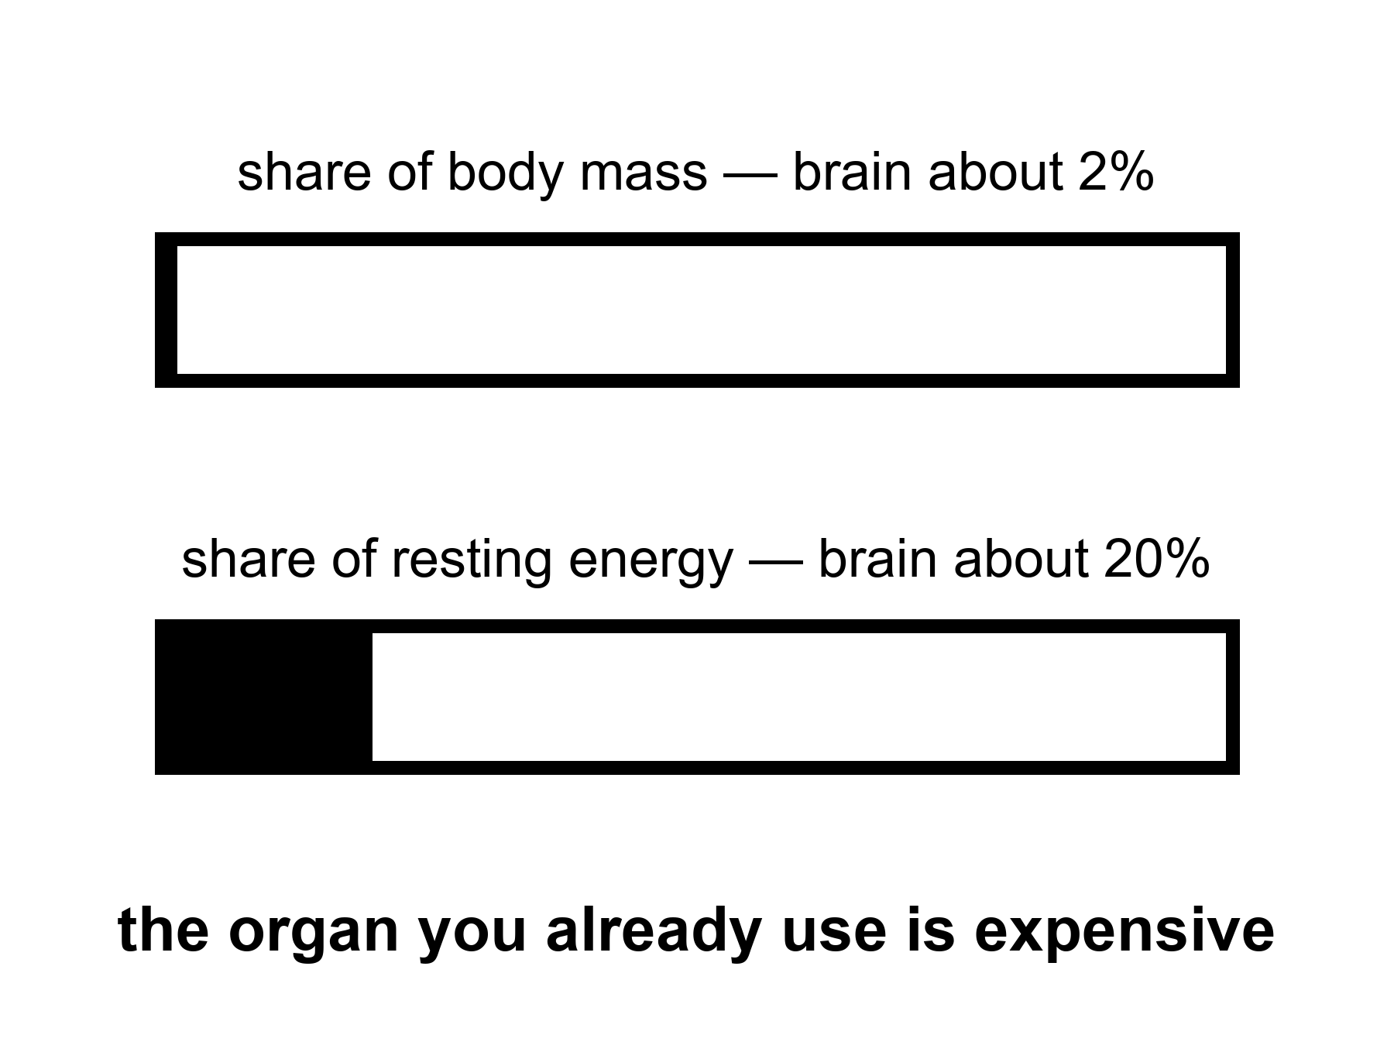
Figure 6. A hatched share: the brain is about two percent of mass and about twenty percent of resting energy. Idle-looking is not off-duty.
The sentence is a zombie because it is flattering. It tells you that the person you already are is a draft. It tells you that a course, a pill, a headset, a founder’s password will open the real draft. It turns a limit into a treasure hunt. Treasure hunts sell. Limits do not.
Where did it come from? Not from a measurement you can cite and keep. It gathered like kitchen grease: a misread of early neurologists who noticed that large injuries sometimes left surprising function; a self-help habit of turning “we do not understand everything” into “ninety percent is waiting”; a cartoon of unused neurons sitting in the dark like unused guest soaps. William James wrote, more than a century ago, that we live below our limits. That is a moral sentence about effort. It is not a volumetric survey of cortex. The ten-percent figure is a mutation of effort-talk into a floor plan. The floor plan is wrong.
Start with the bill, because the bill does not flatter.
The brain is roughly two percent of a body’s mass and takes roughly twenty percent of the resting energy.
where the twenty percent is of resting metabolic rate — the quiet kitchen, not a sprint.
Twenty percent of the quiet kitchen is an outrageous line item for an organ that, in the ten-percent story, is mostly on unpaid leave. Evolution is a miser about watts. A miser does not keep a ninety-percent dark warehouse of tissue that costs like a furnace and does nothing. The wattage is not a vibe. It is glucose and oxygen, measurable in a PET scanner, measurable as a reason you get faint when blood sugar drops, measurable as a reason a small animal with a large brain had better have a good reason. Humans paid the reason: social prediction, language, hands that can bully chemistry, a childhood long enough to load the software. We did not pay for a decorative loaf of unused cortex.
The number is not “twenty percent of thought.” Thought is not a pie you can slice that way. The number is energy. Energy is what a cupboard of idle tissue would still owe. Idle tissue that owed this much would have been fired by the mesh unless it was doing something. The something is the rest of this chapter.
Lesions are the rude teacher.
If ninety percent of the organ were spare, large injuries would be polite. They are not polite. A small clot in the left posterior frontal lobe can take speech and leave the rest of you watching. A strip of motor cortex can take a hand. A hippocampus on both sides can take the ability to mint a new Tuesday. A cut in the white-matter cables — the wiring, not the gray offices — can disconnect a function as surely as removing the office. Stroke maps, tumor maps, gunshot maps, the old wartime files: they are a cartography of on duty. The cartography is not complete. The brain is plastic, and Chapter 14 will not insult that fact. Plasticity is what a staff does when a colleague is gone: overtime, rerouting, a worse but livable shift. Overtime is not proof that the colleague was decorative. It is proof that the remaining staff were already working and can work differently at a cost.
People point at the opposite anecdote: a person missing a startling amount of tissue who can still talk, walk, joke. The anecdote is real and does not rescue the ten percent. Hydrocephalus that thinned the mantle, a hemispherectomy in a child with a raging epilepsy, a slow tumor that stole a lobe while the staff moved: these are demonstrations that development and time can reassign jobs, and that some jobs were already shared. A child is not a cupboard. A child is a construction site. Construction sites can reroute. Adults reroute less, and pay more, and still do not reveal a hidden ninety.
The cerebellum — the hind loaf that looks, to a skimmer, like a bonus — contains a huge fraction of the neurons and is not a bonus. Damage it and you get a drunk walk, a drunk reach, a timing that will not keep a beat. The “extra” neurons were timing the body. They were not waiting for your podcast.
Imaging is the other teacher, and it is easy to lie with.
A functional MRI picture is not a lamp that turns a region on. It is a slow, indirect hint that blood flow changed, which is a hint that cells did more, which is a hint you must not treat as a photograph of a thought. The pictures that make magazines — a blob on a medial surface labeled love — are the worst ambassadors. The honest use is statistical and humble: when a person does this task, this set of regions changes its bill a little, compared with that other task. Almost the entire organ can be shown to change its bill under some contrast if you are patient and not picky. Sensory sheets, motor sheets, language networks, attention networks, a default-mode set that lights when you stop the assigned task and start being a person with a past: they are all expensive. The default-mode set is the one a ten-percent story wants to call idle. It is the opposite of idle. It is the staff that keeps a self, a gossip, a plan, a replay of the argument, a simulation of the orbiter’s next late message. When it is damaged, people do not become superheroes with free watts. They become unmoored.
Tissue that looks quiet in one snapshot is still a staff with a shift you did not catch. A voxel that does not pass a threshold in a love-blob study is not a spare bedroom. It may be working in a way the contrast did not pay to see. It may be inhibitory. It may be waiting, which in nervous tissue is often a job — a ready pool, a tuned silence. Silence can be duty. A night watchman who is not shouting is not unemployed.
Single-neuron recording, where we have it (animals, and the rare human electrode for epilepsy), finds cells that care about astonishingly specific things and cells that care about many things, and very few cells that care about nothing and are just hanging around in case a founder needs them. Glia are not decoration either. They are metabolism, insulation, cleanup, immune mood. The ten-percent sentence sometimes mutates into “we only use ten percent of our neurons,” as if the other cells were packing peanuts. They are not packing peanuts.
Why the zombie survives.
Because unused potential is a kinder story than used limits. Because a school system that fails a child would rather say the child’s tank was never opened than say the organ was on duty and hungry, tired, untaught, or afraid. Because a marketplace of “unlock your mind” cannot sell a hearing aid and a nap as loudly as it can sell a secret switch. Because the phrase is short. False sentences that are short outcompete true paragraphs.
Hot as a correction means you do not get to dress the myth back up as a future. “We only use ten percent today; tomorrow we will use the rest” is the same sentence with a calendar glued on. There is no rest. There is practice, sleep, tools, other people, and a bill. Chapter 7 is the tools with temperatures. Chapter 14 is the expensive rerouting. This chapter is the refusal.
She does not have ninety percent of a mind in the cupboard. She has a morning, a radio delay, a basil plant, a joint that may take a capsule, and an organ that has been paying twenty percent since before she learned the names of the herbs. The organ is why she can name them. It is not waiting for a password to start.
Appendix A6 writes the energy fraction, the lesion logic, and why a quiet voxel is not a spare tank. Here, if you take one thing, take the bill. A miser does not keep a dark warehouse at those rates. You already use the organ.

7. Cognitive Enhancement, Two Temperatures
Cognitive enhancement, two temperatures.
Education, eyeglasses, a hearing aid, a stimulant with a known invoice: warm-to-hot as tools. A chip that returns a lost function: a local fix again, with scars. Unlocking a hidden full brain: cold. Do not dress the myth up as a future.
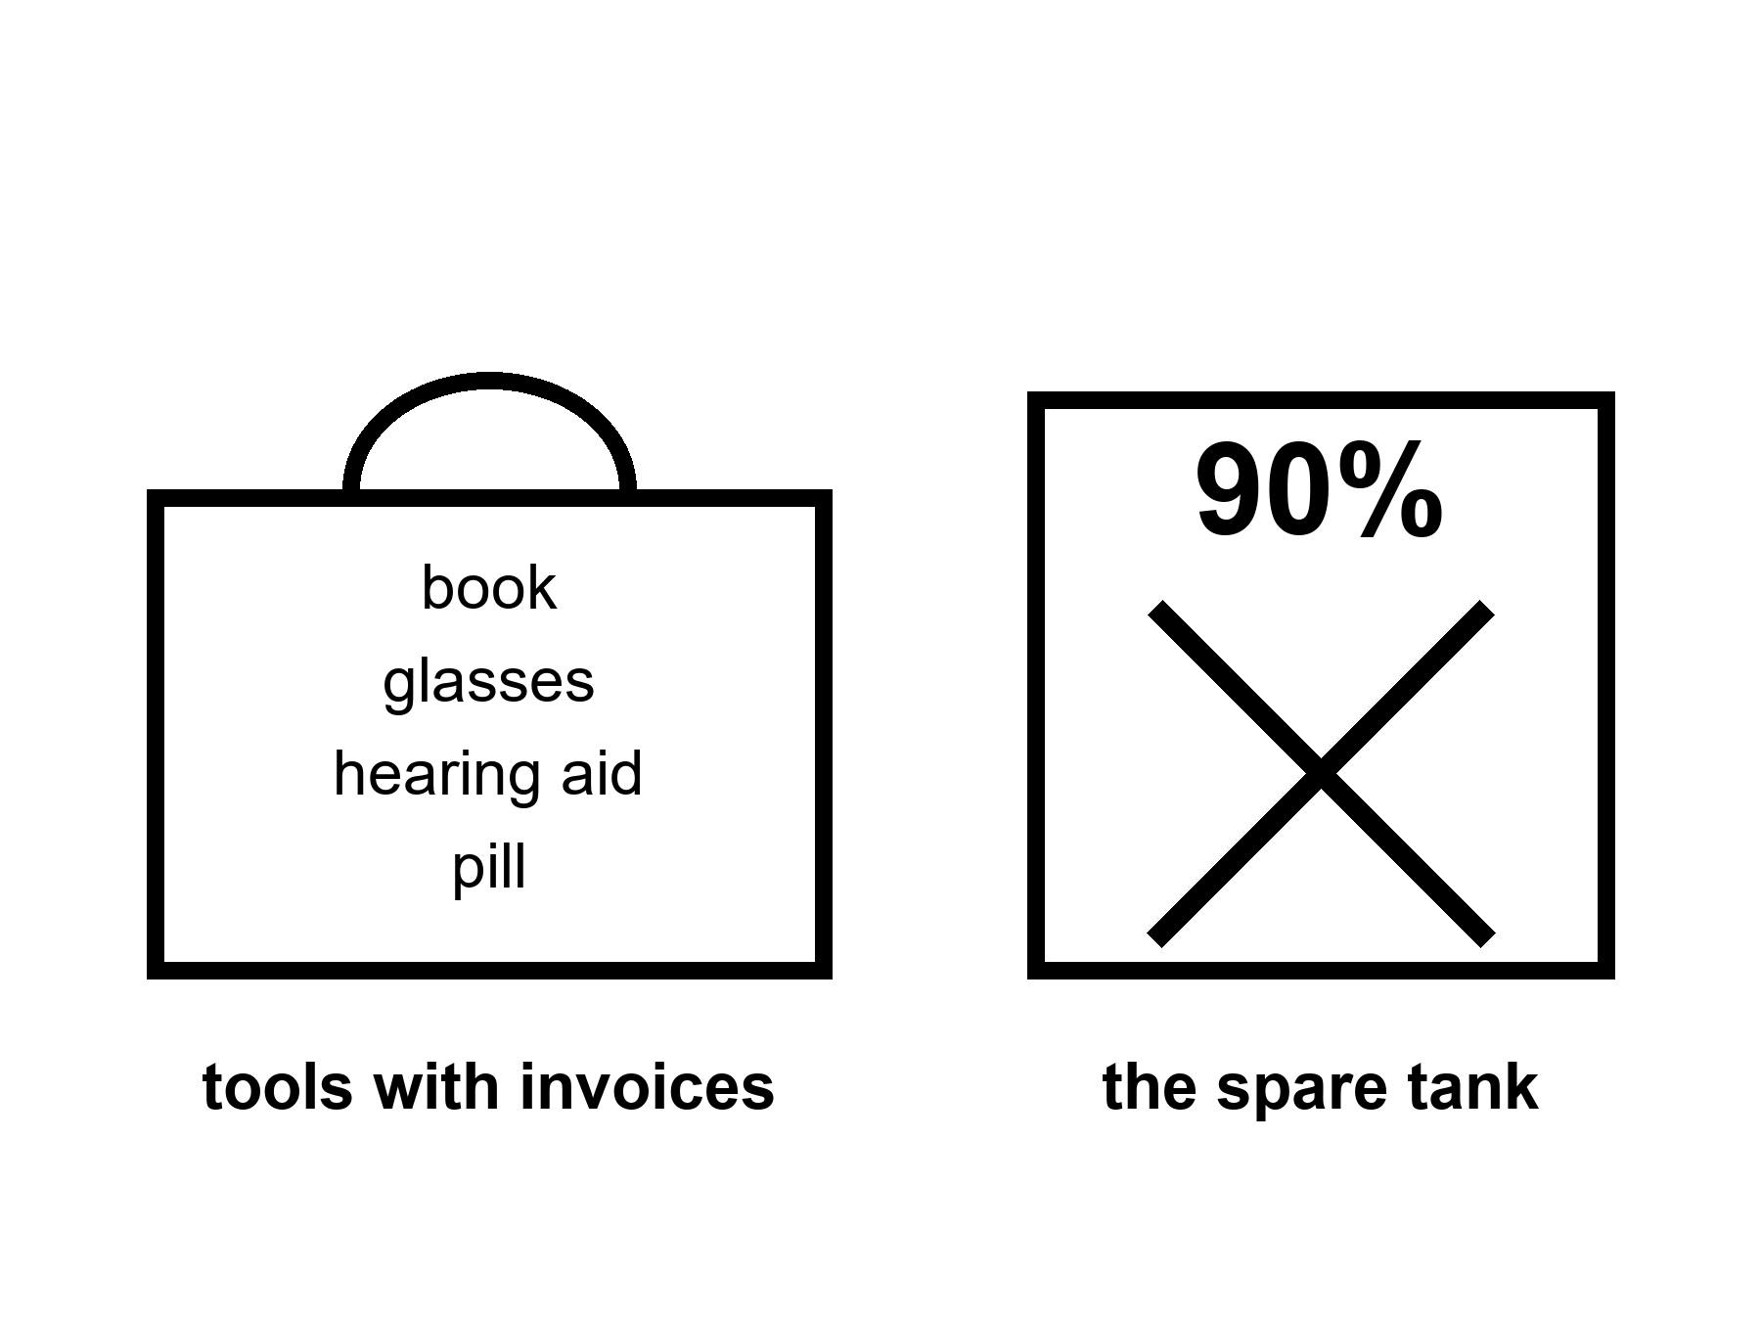
Figure 7. A toolbox on the left — book, glasses, hearing aid, a scored pill. An empty tank marked 90 percent, crossed out, on the right.
A tool is a bargain you can name.
Eyeglasses are the cleanest example in the house. The organ was on duty. The lens in front of it was the wrong shape. A ground piece of glass returns a function the cortex already knew how to use. Nobody serious calls spectacles “unlocking the unused ninety.” They are a local optical fix. They have an invoice. They have side effects if you get the prescription wrong. They changed literacy, craft, and the age at which a person can still thread a needle or read a radio checklist. Hot as a class of win. Not helium.
Hearing aids sit in the same drawer and are more neglected. Hearing is not a luxury input. It is how a social primate keeps the room. When the input fades, the organ does not gain a spare tank. It spends overtime on guessing, withdraws from the conversation, and, in the ugly correlations, walks toward isolation and cognitive narrowing. Aiding the ear is not a miracle for dementia. It is a tool that keeps a channel the brain was already using. The temperature is warm-to-hot as prevention of a preventable narrowing, not as a cure for every plaque. People skip the aid because of vanity and cost and fiddle. They do not skip it because the science said the ear was decorative.
Sleep is a tool that looks like nothing.
It is not nothing. It is clearance, consolidation, a reset of the day’s staff schedule, a metabolic and immune negotiation. Take it away and the organ does not reveal hidden capacity. It reveals a drunk. The last fifty years sold sleep as optional because the lights became cheap. That sale was a mismatch, and Chapter 8 will name the carrot that made the sale easy. Here, the temperature is hot as a requirement and warm as a protocol. How much, exactly, for this person, this age, this job: argued. That you cannot enhance a mind by permanently subtracting the night: not argued, except by people who are selling the subtraction.
Education is the slowest tool and the one that actually moved civilizations.
It is not a chip. It is other people, over years, installing compression tricks — reading, numbers, a trade, a way to notice that a claim has no invoice. It changes what a worldline can do without changing the species. It has a brutal invoice: childhood hours, teachers who themselves had to be made, a state that decides who is in the room. It is hot as a lever. It is cold as a promise that a headset in a weekend will do the same job. The ten-percent story loves the headset because the headset can be boxed. A childhood cannot.
Stimulants are a warmer, messier drawer.
Caffeine is the world’s most popular cognitive enhancer and nobody puts it on a slide next to helium. It buys alertness with a known jitter, a known sleep theft if you take it late, a known habituation. Amphetamine-class drugs, in a person with a diagnosed attention disorder, can be the difference between a life that will vote for Tuesdays and a life that will not. In a person without that disorder, they can be a borrowed morning with an afternoon invoice: appetite, sleep, a heart rate, a temptation to raise the dose when the borrowed morning becomes the new floor. Warm as tools with trade-offs. Cold as a species upgrade. The honest kitchen labels the score. It does not pretend the score is free.
Other pharmacological “enhancers” — a wakefulness drug, a memory-ish candidate, a psychedelic with a therapy wrapped around it — live in the same temperature band when they live at all: small, messy effects, trial-shaped, not a cupboard opening. Many do not live. They live in talks. A talk is cold until a protocol can fail in public.
A chip that returns a lost function is Chapter 4’s logic in metal.
Cochlear implants are the existence proof: a microphone, a processor, an electrode string in a cochlea, a brain that already knew how to do hearing and will, over months, learn this new, cruder code. Scars, batteries, a range of outcomes, a culture argument about what a cure is. Local. A motor-cortex implant that lets a paralyzed person move a cursor or a robotic hand: local, scarred, astonishing, and not a spare-tank unlock. Deep-brain stimulators that quiet a tremor: local. The temperature is hot as restored channel in the cases that work, warm as how far this generalizes, cold as and then we upload the rest. Do not let a restored channel launder a hidden ninety.
What would a real enhancement look like, if we keep the word?
A tool that raises a function above the person’s own baseline in a domain they already had, with an invoice they can name, without pretending the organ was off. Caffeine in a tired surgeon is a small, real instance. A well-taught method for a calculation you used to fumble is a larger one. A future drug that safely lifts working memory by a slice would be news. It would still be a tool. It would still meet the many clocks. It would still meet the carrot. It would not be a different species.
The cold costume is specific.
It says: new challenges are coming — ten thousand years of them, or a Mars city, or a job that does not exist — and therefore we must unlock the unused mind. The “therefore” is a smuggle. New challenges are met the way old ones were: with the organ on duty, with other people, with tools, with time, with institutions that do not snap. Chapter 12 is the meeting. Chapter 14 is the expensive reroute. Chapter 11 is the refusal to let a calendar do physics. Here, notice that the costume needs the ten-percent lie the way a lockpick needs a lock. If the organ is already in use, the unlock is unemployed.
Look first before you overwrite a childhood because a slide said enhancement. A child’s brain is a construction site, not a tank. Stimulants, if they are the right tool, are a tool. A marketplace of “make your child 150 percent” is the carrot aimed at a parent. The parent has a wanting-loop too. The child cannot consent to a species project. They can consent, later, to glasses.
She uses checklists because memory is a staff, not a miracle. She sleeps in a bunk that smells faintly of basil and dust because the organ has a night shift. She does not wait for a chip to make the radio delay shorter. The delay is light. Light is late on purpose. A mind that is already on duty can still be a mind that uses a notebook.
Appendix A7 writes sleep as a bill, hearing as a risk factor, stimulant trade-offs, and implants as local restorations. Here, keep the toolbox and the crossed-out tank. Warm-to-hot as tools. Cold as a cupboard. The next chapter is why the cupboard story feels like a feast.

8. The Carrot Has No Off-Switch
The carrot has no off-switch.
Book 1 said it about a feast and a fake. It is still true if the feast is a long life. You do not need those pages. The loop can be taught in this kitchen. A Pleistocene wanting-loop in a body that lasts 120 years is not a wise king. It is a mismatch with more calendar. Look first before you call that an upgrade.
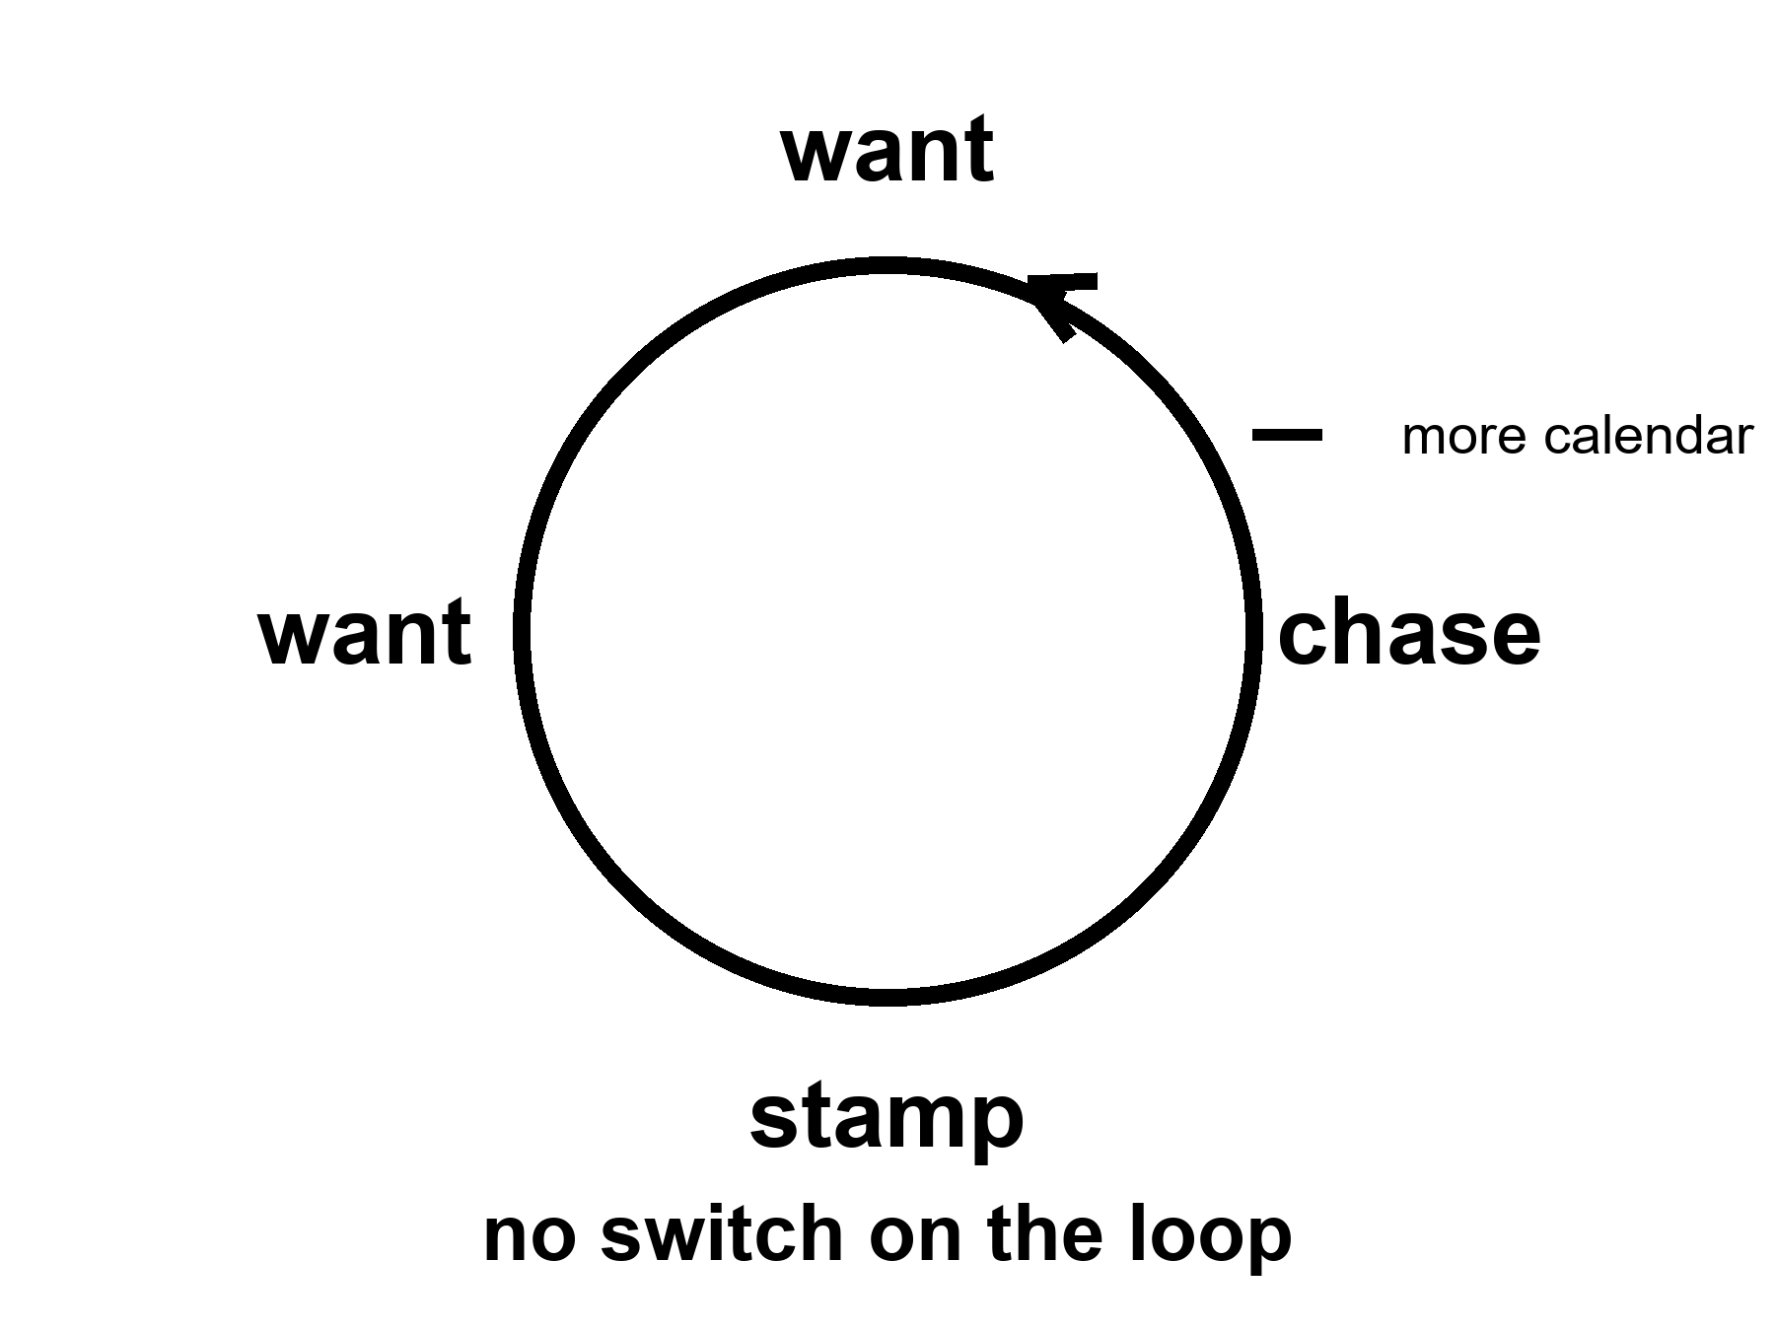
Figure 8. A loop: want, chase, stamp, want. No switch. One extra tick marked more calendar.
Food is not a sandwich. Food is a slope.
A body stays organized by running downhill on a difference: hot to cold, charged to spent, food-molecule to ash. The kitchen name for the ash is waste. Heat is the waste you cannot hide. A nervous system is a staff hired to keep the slopes coming — to find the fruit, the salt, the copy, the ally, the shade. The staff does not mail a pamphlet titled reproduce, then maintain. It mails a carrot. Those who found the act reinforcing left more descendants. Those who found it a chore, all else equal, left fewer. Pleasure is not the cosmic point.
where the point is: a copy that ships, and a body that lasts long enough to ship it.
Wanting is one juice. Liking is another.
Wanting is the seek loop: a cue tagged as worth chasing, a go, a narrowing of the room until the cue is got. Dopamine, in the popular mouth, is this juice, and the popular mouth is not entirely wrong and is too simple. Liking is the completion stamp: do that again. The stamp can be small. The seek can be huge. A person can want a thing they no longer like. A person can like a thing they barely chase. Addiction, in the ugly cases, is a seek loop that has uncoupled from the stamp and from the vote you would cast on a Tuesday. This is not a sermon about vice. It is staffing. The same house hired people who barely want the old feasts, or want a different menu. That is allowed. A lottery that must work on average will throw off quiet tickets.
The carrot has no off-switch labeled this is only a picture.
A gull will sit a giant fake egg in preference to its own. A fish will attack a slab of the right color more fiercely than a rival. That is a supernormal stimulus: the cue, turned up, outbids the thing. We are a primate with cheap infinite pictures, cheap infinite sugar, cheap infinite almost-wins. The factory sells the cue without the invoice — no second person who can leave, no pathogen, no child, a new face every thirty seconds; a cupboard of sweetness that would have been a week of hunting; a feed that never ends. Novelty re-opens the wanting. Industry industrialized the novelty. Hot as a mechanism. Not a verdict on a species, and not a proof that everyone bought a ticket. Plenty of people shrug. Plenty of people drown. Both are allowed by the same wiring.
If you have Book 1, Chapter 30 was this loop in the service of a shuffle and a fake. Courtesy: that is all. The rest of the argument, here, does not need a second origin or a solvent paper. It needs a long life.
A longer life is more calendar for the same loop.
That is the sentence the helium slide does not print.
Give a wanting-loop more Tuesdays and you have not given it wisdom. You have given it more cues. More years to chase a status that will not stamp. More years to open a cupboard. More years to refresh a feed. More years to sit a fake egg because the fake egg is larger than the real one and the off-switch was never hired. Some people will use the years for basil and a log. Some will not. The mesh did not select for a 120-year philosopher. It selected for a seeker who did not die before the copy shipped. The philosopher is a late, expensive hobby of a well-fed ape. The hobby is real. It is not a default setting that clocks in when the joint is fixed.
Look first.
A slide that says enhancement is a cue. It is designed — by people who also have a loop — to tag as worth chasing. The tag can be healthspan, which this book will defend as a product. The tag can be a different species by Friday, which this book will not. The difference is not a mood. It is whether the invoice can be named and whether the many clocks were consulted. A parent chasing an enhanced child is a loop aimed at a construction site. A founder chasing 1,000 years is a loop aimed at a fuse that Chapter 3 said is not on the counter. A reader chasing a spare ninety percent is a loop aimed at a cupboard Chapter 6 emptied.
Mismatch is the grown-up word.
A body built for scarcity meets a kitchen of cheap cues. A sleep system built for a dark night meets a cheap light. An attention system built for a leopard and a gossip meets a pocket that never stops gossiping. A status system built for a village meets a planet of strangers who can see you fail. None of this is new as a complaint. It is hot as a pattern. The new, ruder fact is what happens when medicine becomes good enough to add calendar without adding an off-switch. HIV became a condition and left people with decades the virus would have stolen — a hot win — and those decades are still lived with the same loops, the same cupboards, the same unkind feeds. The win was the decades. The sermon that the decades would automatically become a wise kingdom was cold.
What would an off-switch even be?
Not a lobotomy. Not a moral lecture. A tool, if it exists, would be something that lets wanting stay hired for the mornings you vote for and stay quieter for the fakes you do not. Sleep is a weak, real version: the night ends the day’s seek. A hearing aid is a weak, real version: the room comes back and the isolation-loop loosens. Education is a slow version: you learn to notice a cue that has no invoice. Therapy, for some, is a practice of uncoupling seek from stamp. None of these is a master switch. The cold version is a drug that deletes wanting. That is not enhancement. That is a different kind of chair.
A second origin might have hired a different carrot, or no carrot, or a committee instead of a skull. Courtesy: that zoo is not this book’s. This ape is. This ape’s loop is old, cheap to spoof, and not a king.
She wants the basil to live. That is a loop. She logs the pH anyway. That is a tool she uses on the loop: a measurement that can embarrass a sentiment. The capsule arrives with an optimistic label. The label is a cue. She takes the dose for the joint, which is a Tuesday she would vote for, and not for the species-change, which is a fake egg. The radio is late. Wanting will not make it early. Light does not care.
The honest upgrade, if you want the noun, is not a longer seek. It is more Tuesdays you would vote to repeat, with the seek still in the house, and a kitchen that knows the difference between a tool and a fake. Chapter 2 split the pots. This chapter says why the pots get confused. The carrot will still be running at 80, and at 100, and at 122 if you are the tail. Plan the morning as if that were true. It is.
Appendix A8 writes wanting versus liking, supernormal cues, and why a longer healthspan is not automatically a wiser loop. Here, keep the circle with no switch. Part III is the other cartoon: a real fifty years drawn as a ruler across ten thousand. The carrot loves that ruler. The ruler is not physics.

PART III — Not a Straight Line

9. The Last Fifty Years Were Not a Straight Line
The last fifty years were real. Vaccines that closed rooms of death. A genome you can read without a monastery. Packets that make a radio on Mars feel like a rude kitchen. Compute that got cheaper while we were looking at the basil. None of that is a myth.
None of it is a method for year 12,000.
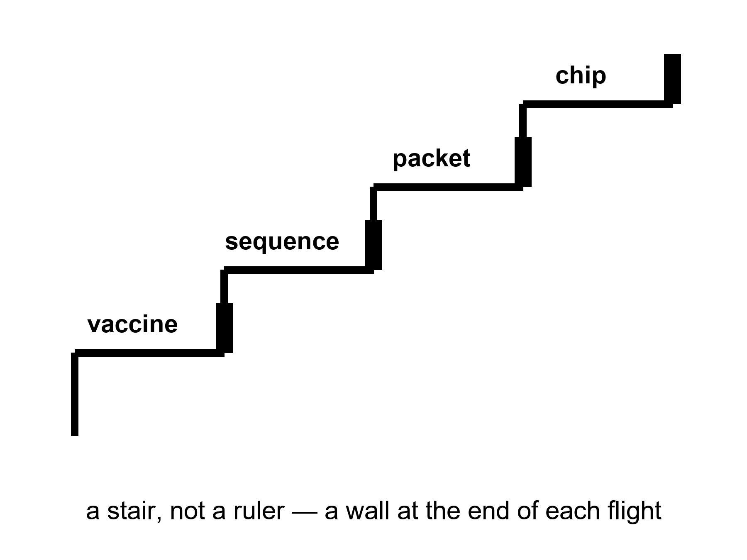
Figure 9. A stair, not a ruler: vaccine, sequence, packet, chip. A wall at the end of each flight.
Hot: the last half-century, in the lucky kitchens, saw uneven, huge gains in a handful of sports. A child in 1975 died of diseases a child in 2025 can miss. Smallpox was already gone; polio was being cornered; measles was a failure of a program when it returned, not a failure of a molecule. Hepatitis B got a shot. HPV got a shot that can close a room of cancers decades later. mRNA platforms, in a pandemic year, turned a sequence into a vial faster than a monastery would have turned a prayer. That is a class of win. It is not a ruler.
A genome you can read without a monastery: the first human draft cost on the order of a billion and a decade of argument. The same order of letters, a generation later, can be a clinic invoice, a consumer curiosity, a research default. The drop is real. The drop is an S-curve with a floor, not a hole through the planet. Chapter 10 is the curve. Here, keep the fact: we learned to read a book we already had, cheaper.
Packets: a radio on a dead world that can carry a voice, a picture, a software load, a slipped date. The delay is still light. The clarity is a gift of coding, of error correction, of a network that treats a bit as a bit. Cheap compute sat under the packets and under the sequences and under the slides that now abuse both. A machine that fits in a pocket and outruns a room that used to fill a basement is a real stair. The stair has a wattage, a mine, a dump, and an attention bill. The walls have names.
The walls were always in the house.
Energy. A bit is cheap. A civilization is not a bit. Aluminum, ammonia, steel, a data hall that wants a river, a camp that wants a reactor, a body that wants a thousand watts of food-and-heat: these do not follow a transistor curve. They follow mines, grids, politics, thermodynamics. The last fifty years made some of this cleaner in some zip codes and dirtier in others. They did not repeal heat.
Materials. You can print a model of a pump. You cannot yet print a spare civilization. Rare earths, copper, lithium, a catalyst, a sterile vial, a glove that survives dust: each has a supply chain that can snap. The last fifty years globalized the chain and called the globalization a law. A pandemic and a war taught the kitchen that a chain is a choice.
Attention. A pocket that never stops is not an extra brain. It is a cue factory aimed at Chapter 8’s loop. The last fifty years invented a way to spend a species’ mornings on a feed. That is a gain only if you liked the feed. It is a wall if you wanted the mornings.
War. The same decades that sequenced a genome also spent treasure and blood on fronts that ate both. Knowledge can be lost in a fire. A lab can be a crater. A generation of technicians can be a grave. Progress is not a law that fires if we wait. Institutions fail. Chapter 12 is that failure with the lights on.
None of this cancels the stairs. It stops you from laying a ruler on them and calling the far end a kitchen you can name.
Ibrahim Sorel teaches a history of techniques, not a history of posters. He is invented. His board has two columns: what got cheaper and what did not. Vaccines, sequences, packets, transistors: cheaper, then slower, then a wall. Hospital cleaning, a night nurse, a peace, a grid that stays up in a heat wave: not cheaper in the same way, and sometimes dearer. He will not let a student draw a line from 1975 to 12,000 and write therefore. Therefore is a smuggle.
Mara’s radio is a packet gift and a light-time insult. The gift is fifty years. The insult is Einstein, who is older. She logs the pH with a meter that used to be a lab and is now a tool. The tool is a stair. The basil is still a plant. The plant does not care that the meter got cheaper. The plant cares that the film is honest.
A ledger of the uneven, so “the last fifty years” cannot mean one kitchen.
In the lucky zip codes, childhood death became rare enough to forget, which is how it becomes possible again. In other zip codes the same decades were a fight to keep a fridge cold and a nurse paid. A global average of life expectancy rose, then stumbled, then rose in pieces. HIV became a condition where the pills arrived and stayed a cliff where they did not. A sequence got cheap in a lab that already had a staff, and stayed a rumor in a clinic that did not. Packets made a radio on Mars rude and clear, and made a feed that ate mornings. Compute got cheaper and then spent the savings on a hall that drinks a river so a model can guess the next word.
Ibrahim will not let “we” stand in for that ledger. We sequenced. We vaccinated. We invented a pocket. Some of us did. Some of us received. Some of us were the mine. The stair is real. The pronoun is a costume if it erases the invoice.
Mara’s meter is a lucky-zip-code object that rode a cargo to a dead world. The sister’s clinic is a different S-curve. Both are this species. Only one of them is in the poster.
Appendix A9 writes the class of wins — vaccines, sequencing, packets, compute — and the named walls. Here, keep the stair. Do not bring a ruler into this room. The next chapter is the shape of a stair that everyone pretends is a rocket.

10. S-Curves and Invoices
Progress is logistic more often than exponential. Diminishing returns are a kitchen fact.
An S-curve is a slow start, a drunk middle, a wall. The wall is not a moral. The wall is what a kitchen looks like when the easy fat has been skimmed: the first half of the dirt is cheap to clean, the last corner is a career.
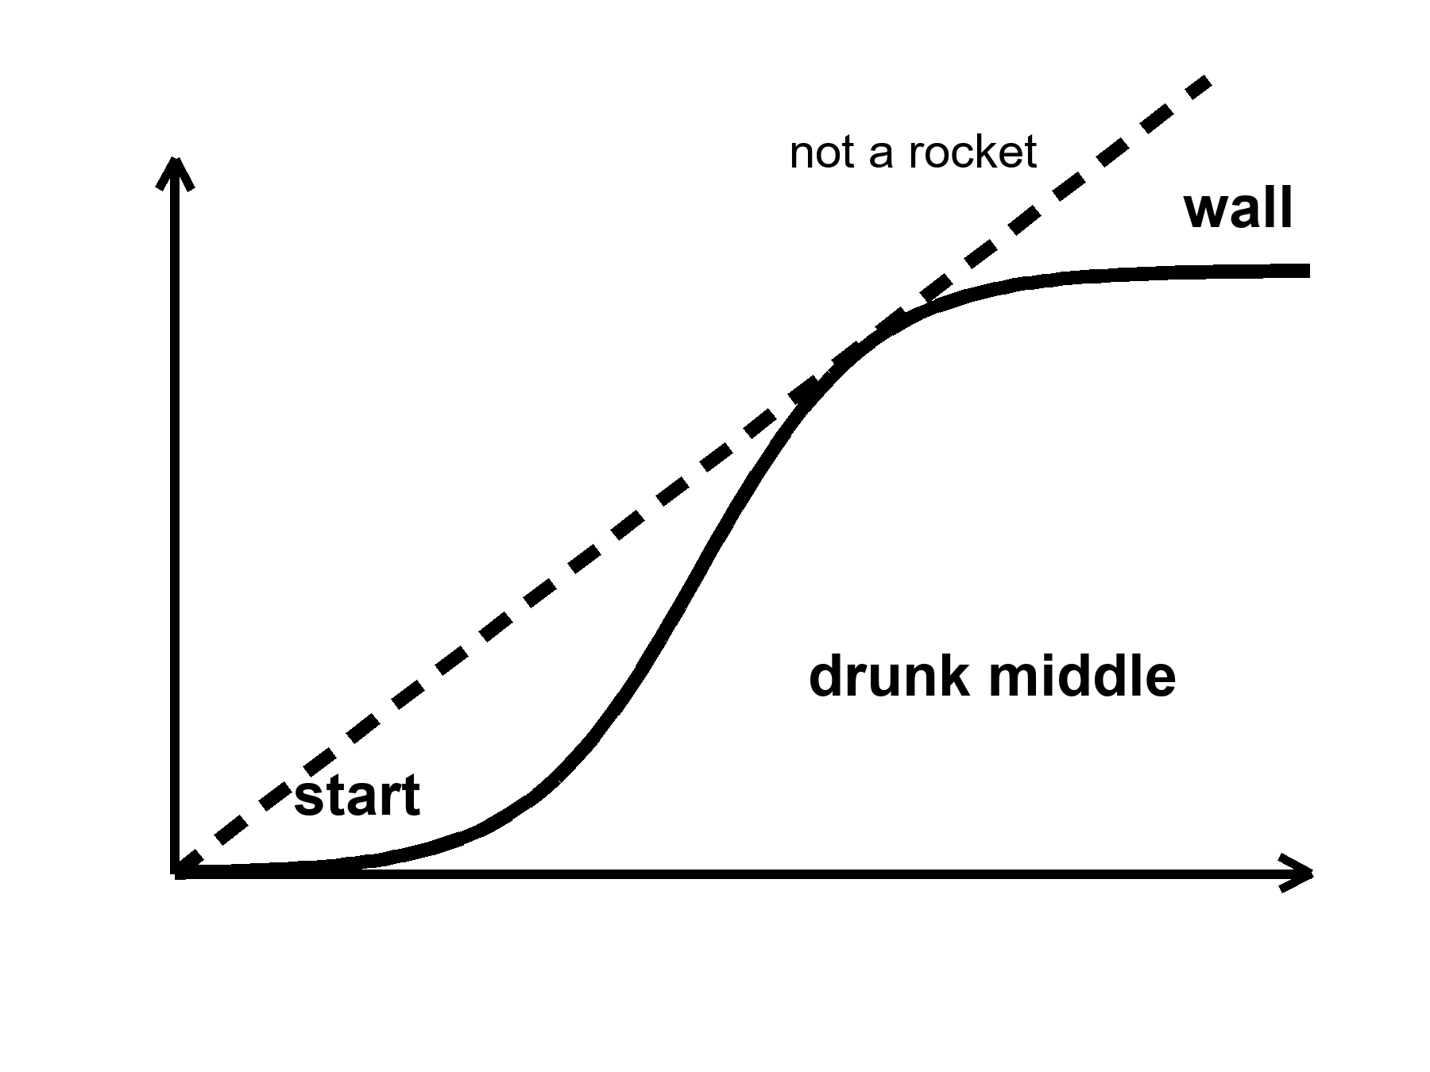
Figure 10. One S: slow, steep, flat. Labels: start, drunk middle, wall. Not a rocket.
where a logistic is a growth that feeds on what is left to gain, and therefore slows as the room fills.
Moore’s law was a social-engineering miracle dressed as physics: pack more switches, keep the bill tolerable, do it on a calendar an industry can bet a factory on. For decades the middle was drunk. Then the watts per switch stopped being polite, the lithography became a cathedral, the next nanometer became a diplomacy. The curve bent. You can still buy more compute. You buy it with parallelism, with specialist chips, with buildings that drink rivers, with a bill that is no longer a hobby. The sermon that “compute doubles forever” was a middle-of-the-S costume. The costume sold a lot of slides. The wall is not a scandal. The wall is an invoice.
Sequencing rode a steeper drunk years and then met its own floor: the machine is cheap compared with a billion, the meaning is not. A clinic can read a genome and still not know what to do with most of the letters. Interpretation is a staff. A staff is an S-curve of training, liability, and a library of what the letters actually do. The drop in dollars-per-base was real. It was not a drop in dollars-per-wisdom.
Vaccines had S-curves before anyone drew one. The first clean hits — a toxin you can tame, a virus you can weaken — were drunk middles after long starts. The leftover diseases are ruder: a moving target, a poor market, a body that will not keep a title, a politics that will not keep a schedule. mRNA was a new stair in a platform. It did not make every illness a weekend.
Medicine as a whole is a museum of S-curves. Antibiotics had a drunk middle and then a wall named resistance and a wall named “the easy soil is mined.” Heart disease had a drunk middle of pills and stents and a wall of metabolic weather that is a farm and a street. Cancer had many small S-curves, disease by disease, and a leftover that is still a funeral. Imaging got cheaper and then met the bill for the person who has to read the image.
Why the rocket story sells.
Exponential is a feeling. It is a middle of an S photographed without the shoulders. A founder who lived through the drunk years of packets and chips thinks the photograph is a law. A law would not care about energy, materials, attention, or a meeting. A kitchen cares. Diminishing returns are what you get when the next unit of gain costs more than the last: more money, more energy, more rare staff, more side effects, more political fight. The last fifty years skimmed a lot of fat in a few sports. The next fifty, in those same sports, will pay more per increment if the shape is what the shape has usually been.
Warm: whatever is invented will still pay energy, coordination, and the body’s invoices. That is not a proof that nothing new will be invented. It is a proof that the invoice will not be waived because the slide is steep.
Cold: progress is guaranteed if we wait. Knowledge can be lost. A grid can fail. A library can burn. A generation can be taught a smaller book. The loaf, if you met it in the longer volume, does not owe a sequel. You do not need that volume. You need the kitchen fact: waiting is not a method.
Priya Nair draws S-curves on napkins for people who arrived with rockets. She is invented. The napkin is a kindness. She has watched a sequencing lab go from a cathedral to a bench and then stall on a variant of unknown significance. She has watched a chip shop go from a miracle to a diplomacy. She likes both. She will not extend either with a ruler to a year that has no furniture.
Mara’s meter got cheaper. The ice did not. Melting the ice is energy and a pump and a morning. The pump has an S-curve: the first reliable pump was a career, the tenth was a spare, the hundredth is a supply chain from a world that still has to send it. She logs the pH. The log is a tool. The tool will not become a fountain because the last fifty years were impressive.
Appendix A10 writes logistic shape, Moore’s bend, and sequencing’s dollar drop as a table. Here, keep the S. The next chapter is the arithmetic abuse that turns fifty into ten thousand.

11. Ten Thousand Years Is Not ×200
Fifty into ten thousand is two hundred. That is arithmetic. It is not physics.
Claim, cold: last fifty × 200 = the furniture of the year 12,000. We cannot name that furniture. Do not print a 10,000-year gadget catalog. The catalog would be a costume, and the costume would be wrong in both directions: too shy about accidents, too loud about transistors.
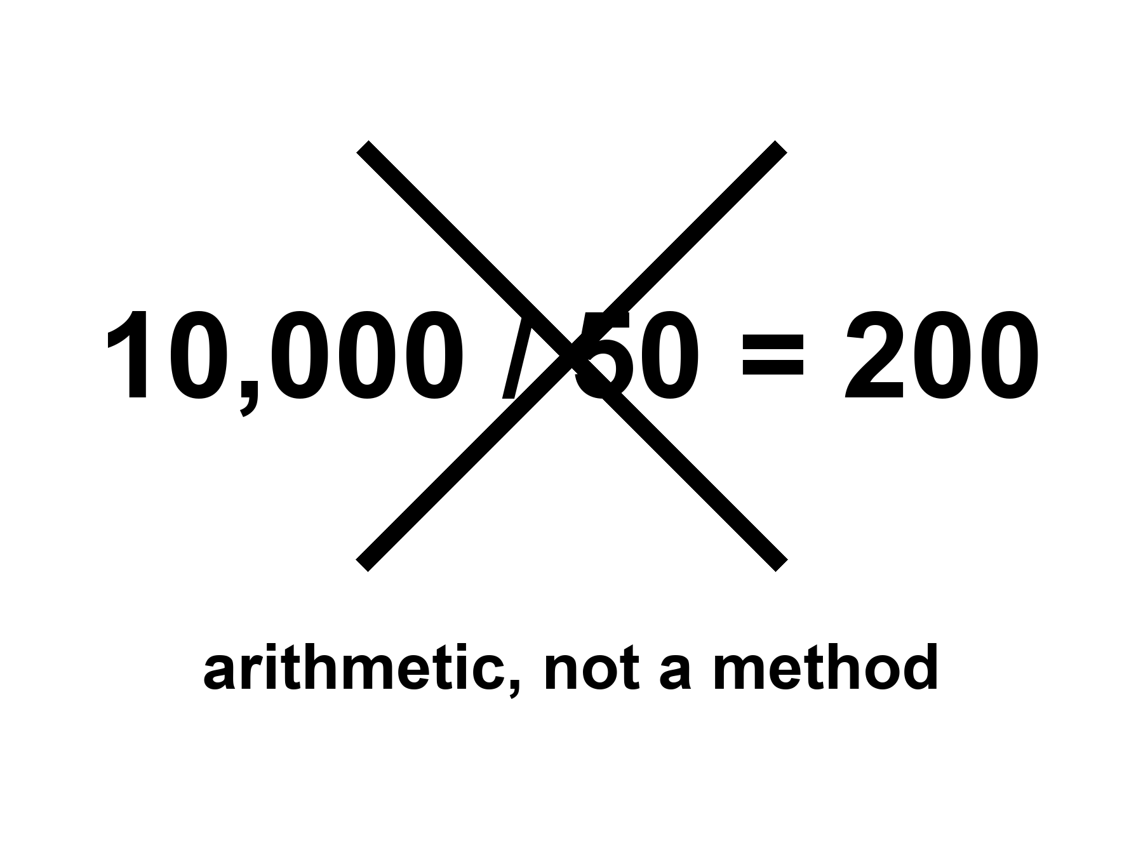
Figure 11. 10,000 / 50 = 200, crossed out. The label: arithmetic, not a method.
where 10,000 / 50 = 200 is a ratio of years, not a law that copies a kitchen 200 times.
What the abuse does: it takes a drunk middle — cheap bits, cheap letters, a vaccine platform — and treats it as a slope that continues through walls, wars, and the body’s many clocks. It then names the far kitchen as if naming were a forecast. Flying cities, helium bodies, spare brains, a mind in a file, energy too cheap to meter, a politics that finally agrees. None of that is selected by a ratio.
What an honest extrapolation is allowed to say:
Energy will still have a bill. Heat will still have to go somewhere. Coordination will still be a meeting, a ledger, a front. Biology will still be many clocks. Knowledge will still be losable. Children will still need a childhood that was not overwritten because a slide said enhancement. We cannot name the gadgets. We can name the invoices.
A gadget catalog for the year 12,000 is cold as a method and rude as a promise. This chapter will not write one. If a later reader lives in a kitchen we cannot imagine, they will not need our catalog. If they live in a poorer kitchen, because a war or a dark age or a simple failure of staff, they will need the invoices more than they need our optimism.
People reach for ×200 because the last fifty felt like more than a lifetime of change. Felt is a measurement of surprise, not of slope. A person born in 1975 met packets, a cheaper genome, a quieter childhood disease, a louder pocket, a climate needle that did not droop. That is a lot of furniture to rearrange in one career. Rearrangement is not a license to multiply the career by two hundred. The century before last rearranged furniture too: engines, wires, vaccines of an older class, a war that ate a generation. If you had multiplied that fifty by two hundred, you would have printed a 3900s kitchen that was all steam and no transistor, or all transistor and no steam, depending on which drunk middle you photographed. The method fails in the rearview. It does not get a promotion because we like this rearview better.
Look first. A slide that says the next 10,000 years of medicine and then shows a 200-year ape is not forecasting. It is Chapter 8’s carrot with a calendar. The calendar is a cue. The ape is a fake egg.
She will not see year 12,000. No one she can radio will. The loaf, if you like the courtesy, already has that year as a region; you cannot rent it. The honest body is a morning. The morning has a pH. The pH is not a gadget from a catalog. It is a number a plant will die over.
A worked example, so the arithmetic has to sit in public.
Take vaccines in the lucky kitchens. Fifty years moved a lot of rooms from death to boredom. Multiply that motion by two hundred and you do not get a 10,000-year ape who cannot get sick. You get a nonsense: either every remaining pathogen politely resigns, or you have invented a biology that is not this biology. The leftover rooms — a moving flu, a poor-market parasite, a politics that will not hold a cold chain — are the wall the ratio waived.
Take compute. Fifty years packed switches until the packing became a cathedral. ×200 is not two hundred more cathedrals of the same kind. It is a wish that heat, lithography, and mines will keep pretending to be a hobby.
Take sequencing. The read got cheap. The act — this letter, this tissue, this trial, this zip code — did not get two hundred times cheaper, and will not, if Chapter 13’s invoices are real.
The method fails the moment you name a sport. That is why the catalog is refused. A catalog is a list of sports with the walls deleted.
Appendix A11 writes the ratio, the rearview failure, and a short list of invoices that will still be due. Here, keep the crossed-out sum. If a founder shows you a skyline labeled 12,000, ask which wall they waived and which war they cancelled.

12. Coordination, Wars, Institutions
The limit is often a meeting, a ledger, a famine, a front — not a transistor.
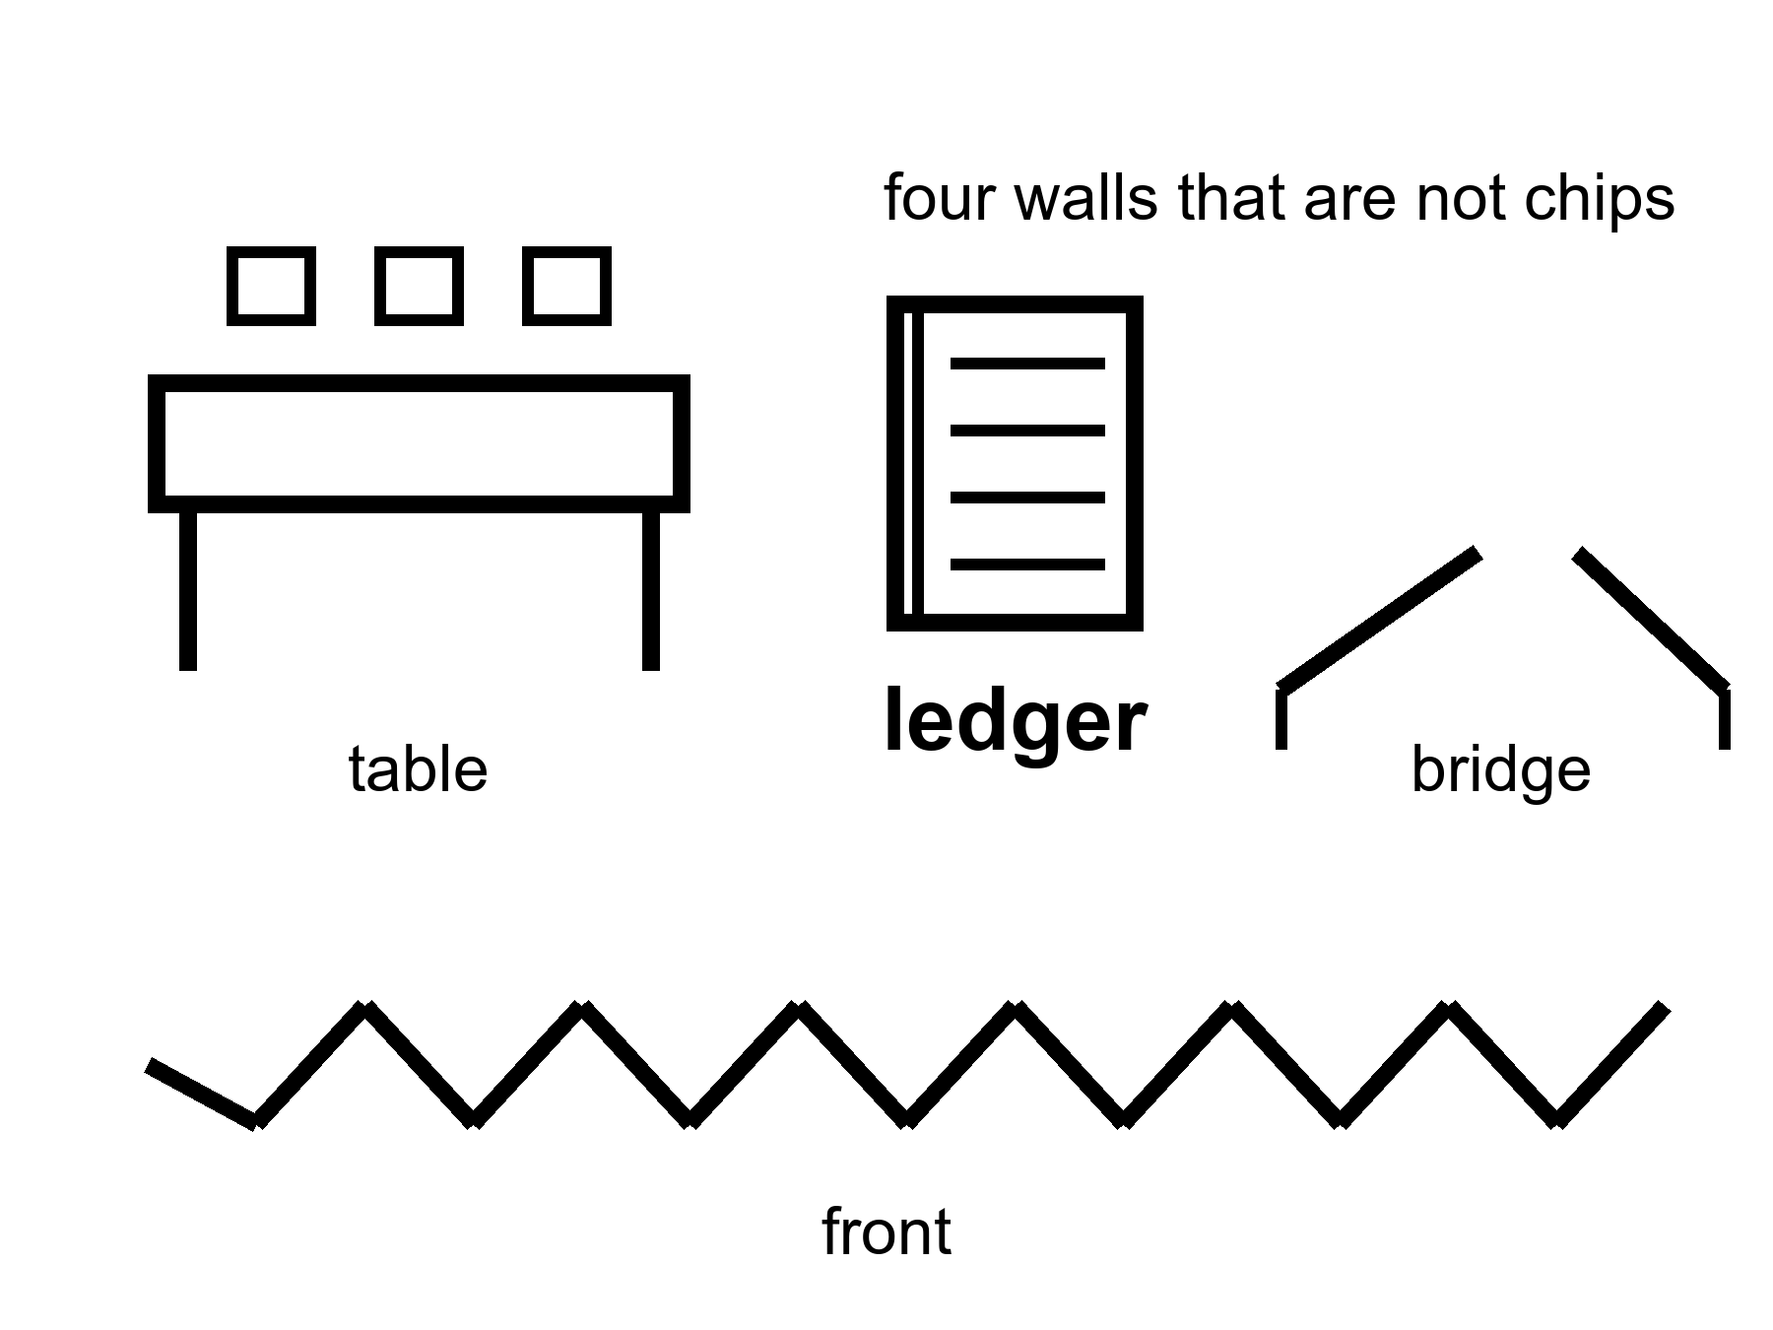
Figure 12. A table, a ledger, a broken bridge, a front. Four walls that are not chips.
A transistor does not vaccinate a neighborhood. A neighborhood is a schedule, a fridge, a rumor, a nurse, a person who will not come because the last campaign lied. A transistor does not keep a grid up in a heat wave. A grid is a union, a spare transformer, a politician who approved the spare, a copper mine, a storm. A transistor does not close a loop on a dead world. A loop is Chapter 12 of the other book’s three nouns, and this chapter’s meeting.
Institutions are slow kitchens. They store the method for running a trial, paying a nurse, keeping a river drinkable, not shooting the technician. When they work, they look like boredom. When they fail, they look like a sudden return to a ruder century. The last fifty years, in the lucky zip codes, were an institution story as much as a chip story: agencies that could still say no, journals that could still retract, a cold chain that could still hold a vial. In the unlucky zip codes they were an institution story too: a clinic that closed, a ledger that was stolen, a front that ate the graduates.
War is not a subplot. War is a way knowledge dies and a way knowledge is hurried. A front can produce a vaccine schedule and a crater in the same decade. A species that wants a 10,000-year catalog must first want a 10,000-year habit of not burning the library. That habit is not selected by a slide. It is selected, if at all, by politics, which is a meeting that can fail.
Famine is an energy and coordination failure with a body count. It does not care that a lab can edit a letter. It cares that a crop failed, a road was cut, a price was a weapon. The body keeps its own clock; a hungry body keeps a faster one.
Germline enhancement as a front, not a gadget.
Chapter 4 left a door closed. Changing the string in a child who cannot consent is technically closer than it was. It is still a meeting, a law, a church, a market, a fear, a race between ledgers. A front is this chapter’s kind of wall. Look first. A slide that says enhancement about a childhood is the carrot with a new face. The off-switch was not hired. This book will not print the catalog of designer children. It will name the invoice: you do not overwrite a construction site because a ruler said year 12,000 would thank you.
Owen Hale chairs a board that decides which local fix a hospital can afford this year. He is invented. The board is real in a thousand towns. He has a sickle-cell-class win on the table and a line of other doors, and a budget that is a political weather. The transistor that made the win possible is not in the room. The ledger is. The meeting is. A war two seas away is in the room as a price. He does not feel like a villain. He feels like a kitchen. The kitchen is the limit more often than the enzyme.
Mara hears, on the delay, that a date slipped because a module did not leave a factory. The factory is an institution. The slip is Chapter 3 of the destinations book, if you have it; you do not need it. A meeting moved a year. A year is not destiny. A meeting is not a transistor. She logs the pH. The plant does not have a board. The plant has a chemistry. The chemistry can be bullied. The bullying still needs a spare part from a world that still has meetings.
Appendix A12 writes institutions as a failure mode, war as a knowledge risk, and why a trial is a meeting. Here, keep the table. Part IV is the invoices on the body itself: who gets the local fix, what plasticity actually costs, why a file is not a life, and the morning that is left when helium is put down.

PART IV — The Honest Body

13. Medicine’s Invoices
A local fix is a win with a bill. The bill is not only money. It is a trial that can fail, a side effect that can stay, a conditioning regimen that is not a vitamin, a zip code that was not invited.
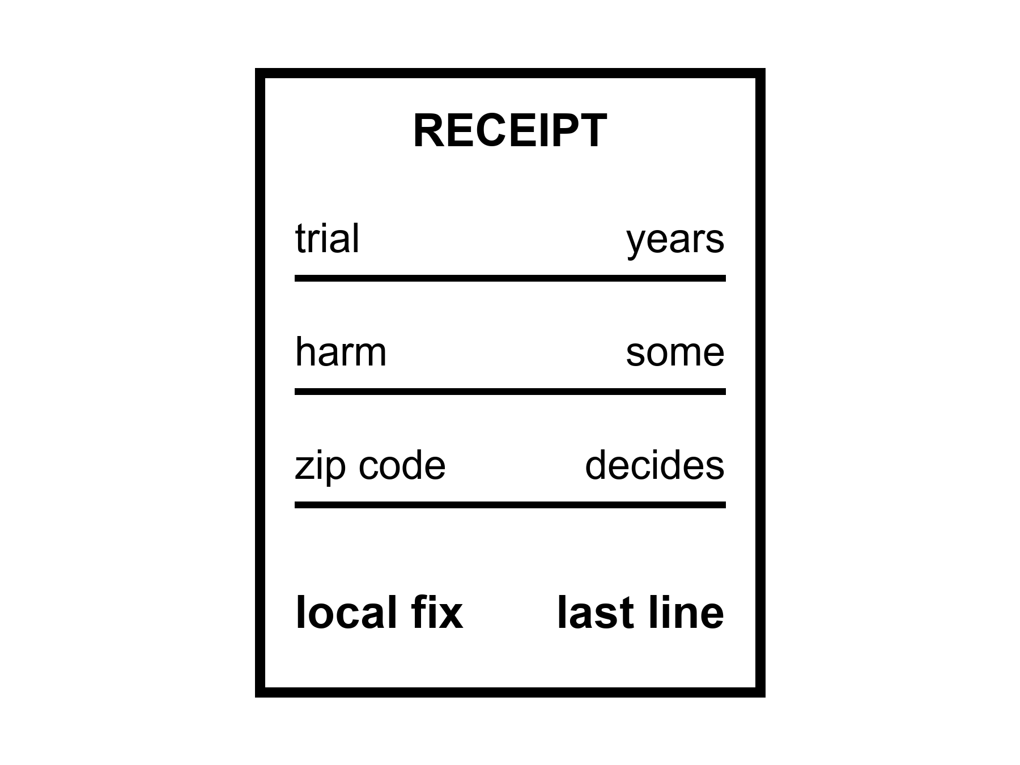
Figure 13. A receipt: trial, harm, zip code. The local fix is on the last line, not the first.
Hot as a class: sickle-cell-class edits, a handful of enzyme replacements, a retinal truck, a CAR-T that hunts a blood cancer, a hip, a cataract, a pill that turns a cliff into a negotiation. Cold as a default: everyone shares those gains. The invoices are unequally paid.
A trial is how a kitchen refuses to take a founder’s word. It is slow, expensive, rude to hope, and still the least-bad way we have learned to not poison a population with a story. Trials fail. They fail because the trick did not work, because the trick worked in a mouse, because the trick worked and the harm was louder, because not enough people could be found, because a war moved the staff. A failed trial is not a proof that the next letter cannot be edited. It is a proof that the invoice includes a no.
Side effects are not fine print. They are the entry fee. Wipe a marrow to make room for an edited lineage and you have bought a month that can kill you on the way to a life that can save you. A drug that clears a plaque and also rattles a vessel is a negotiation, not a halo. A stimulant that buys a morning and steals a sleep is Chapter 7’s toolbox with the lights on. Naming the fee is not pessimism. It is the difference between a tool and a sermon.
Who pays.
A price in the low millions per person, in present ledgers, is a local fix that a kingdom can buy for a few and a village cannot buy for its own. Insurance, a ministry, a charity, a lottery of a lawsuit: these are the real delivery trucks for many of the wins. Delivery of the molecule was Chapter 4’s problem. Delivery of the payment is this chapter’s. Modest further healthy-year gains this century in rich-country medicine are warm. Everyone shares them: cold. The same decades that cheapened a sequence did not cheapen a hospital night in some ledgers; they dearened it. An S-curve in a lab is not an S-curve in a bill.
Inequality is not a subplot you add for manners. It is a clock. A body in a zip code without a trial site does not have the same many clocks as a body next to a campus. The clocks are the same biology. The access is a different pot. Healthspan as a product, if it remains a rich-country hobby, is a product that will be sold as a species story and billed as a membership.
Look first. Do not overwrite a childhood in a poor kitchen because a rich kitchen’s slide said enhancement. The child in the poor kitchen may need a vaccine that already exists and a fridge that already exists. The slide likes the new scissors. The fridge is ruder and hotter.
What a trial is, when you sit still with it.
Phase 1 asks: does this kill you on the way in? A handful of people, a dose that climbs, a staff that watches a liver number. Phase 2 asks: does anything useful happen, and to whom? Phase 3 asks: compared with what we already have, in enough bodies that a statistic can be rude. Phase 4, if you get there, is the kitchen after the press release — rare harms, real zip codes, a trick that was clean in a campus and messy in a night clinic. Each phase is a meeting. Each meeting can say no. A no is not a conspiracy against helium. A no is how you do not staff a funeral with a slogan.
Mice lie in a particular way. They live fast, they are inbred, they do not pay rent, they do not have a seventy-year atherosclerosis, they do not have a human immune memory of a century of viruses. A mouse that lived longer is a paper. A paper is allowed. A paper is not a woman at an airlock. Translation is the unpaid invoice of every fountain slide. Chapter 3 already said the clocks are many. Translation is why a shout at one clock in a mouse dies in a woman who is still running five.
Dr. Anjali Mehta enrolls people in a trial and then sits with the ones the trial did not choose. She is invented. The sitting is the job. She has a win on her wall and a stack of letters that say not eligible. Eligible is a biological word and a geographic word and an insurance word. She will not let a founder use her wall as a downtown. The wall is a door that opened for some. Chapter 5 already said the house has other doors. This chapter says some houses do not get a carpenter.
Mara’s capsule has a label and a delay. Someone paid. A ministry, a contractor, a theater of “crew health.” She takes the dose for the joint. She does not become a different species, and she does not become a proof that the sister on the coast will get the same dose. The sister will get, if she is lucky, the boring wins: a blood-pressure pill, a vaccine, a surgeon who can still be afforded. Boring is hot. Helium is cold.
Appendix A13 writes trial phases, harm as an entry fee, and price-as-delivery. Here, keep the receipt. The local fix is the last line. The first lines are how you got to sit at the table.

14. Adjusting Is Not Spare Capacity
Plasticity is real and expensive. We meet new challenges with the organ we have, plus tools, plus other people. That is already the method. It is not a tank of unused mind waiting for a password.
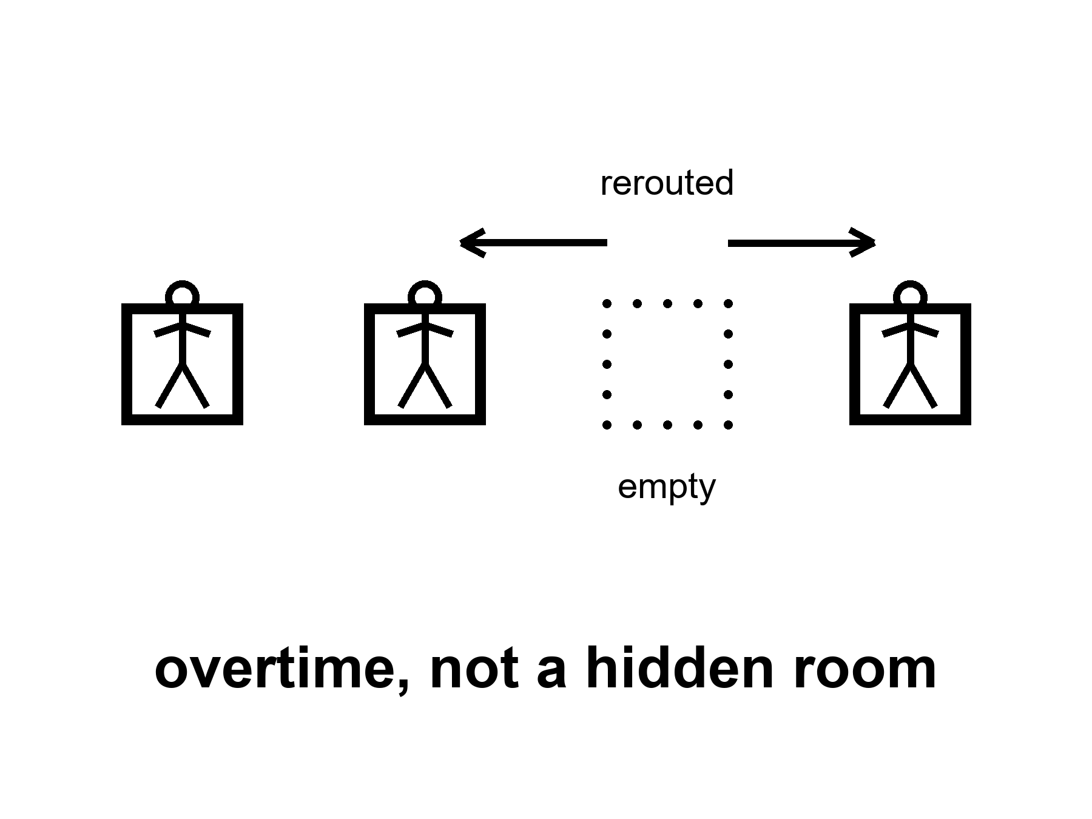
Figure 14. A staff rerouting after a chair is empty. Overtime, not a hidden room.
Hot: a brain can change what it does. Practice thickens a skill. Sleep consolidates. A child can lose a hemisphere and still talk, later, with a cost. An adult can recover a piece of a hand after a stroke, with a year of ugly work. A musician’s map of the fingers is not a civilian’s. A taxi driver’s map of a city, in the old days of paper, was a hippocampus that had been hired extra. None of this is a spare ninety percent. It is a staff doing overtime and rerouting.
Expensive is the word the ten-percent story skips.
Rerouting costs time, watts, frustration, a therapist, a family that will walk the same hallway a thousand times, a sleep that must actually happen. It costs the function you borrowed from. A skill you thicken can thin a neighbor if you are not careful; more often it just eats the mornings you would have spent on a different skill. A child construction site can reroute more cheaply than an adult office. That is development, not a cupboard. Adults pay more per increment. Diminishing returns live in skulls too.
Tools are part of the method, not a confession of failure. Writing is a tool. A checklist is a tool. A hearing aid is a tool. A notebook on a dead world is a tool. Other people are the oldest tool: a crew, a kitchen, a science that is a conversation with the dead and the delayed. A species that meets a new challenge by inventing a tool and teaching it is not a species that had ninety percent off. It is a species that was already on duty and hired help.
New challenges — a climate needle, a new pathogen, a camp on a dead world, a job that does not exist yet — will be met this way or not met. They will not be met by unlocking a hidden loft. Chapter 6 emptied the loft. Chapter 7 put tools on the table. Chapter 8 said the carrot will try to sell the loft again. This chapter is the labor: overtime, not helium.
A second origin might have hired a web, a committee, a mind that is only itself when plugged into itself. Courtesy: that zoo is not this book’s. This ape adjusts with this skull, this sleep, this staff of other apes, this notebook. It is already a great deal. It is not a spare tank.
She learns a new pump the week the old one dies. The learning is ugly. Rohan already knew the pump. She did not. Plasticity is Rohan talking and her hands doing the wrong thing twelve times and then the right thing. No cupboard opened. A colleague and a tool and a morning she would vote for because the water still has to melt. She logs the pH. The log is part of the adjustment. Sentiment named the basil. The log kept it alive.
Appendix A14 writes stroke recovery, sensitive periods, and practice as a bill. Here, keep the overtime. Adjusting is not spare capacity. It is the capacity you already had, spent.

15. Copies, Uploads, and Cold Immortality
A file is not a worldline.
Cold: a mind poured into a machine, running forever, you in the pour. Allowed as a story. Not selected by present levers. Not selected, either, by a careful reading of what a copy is.
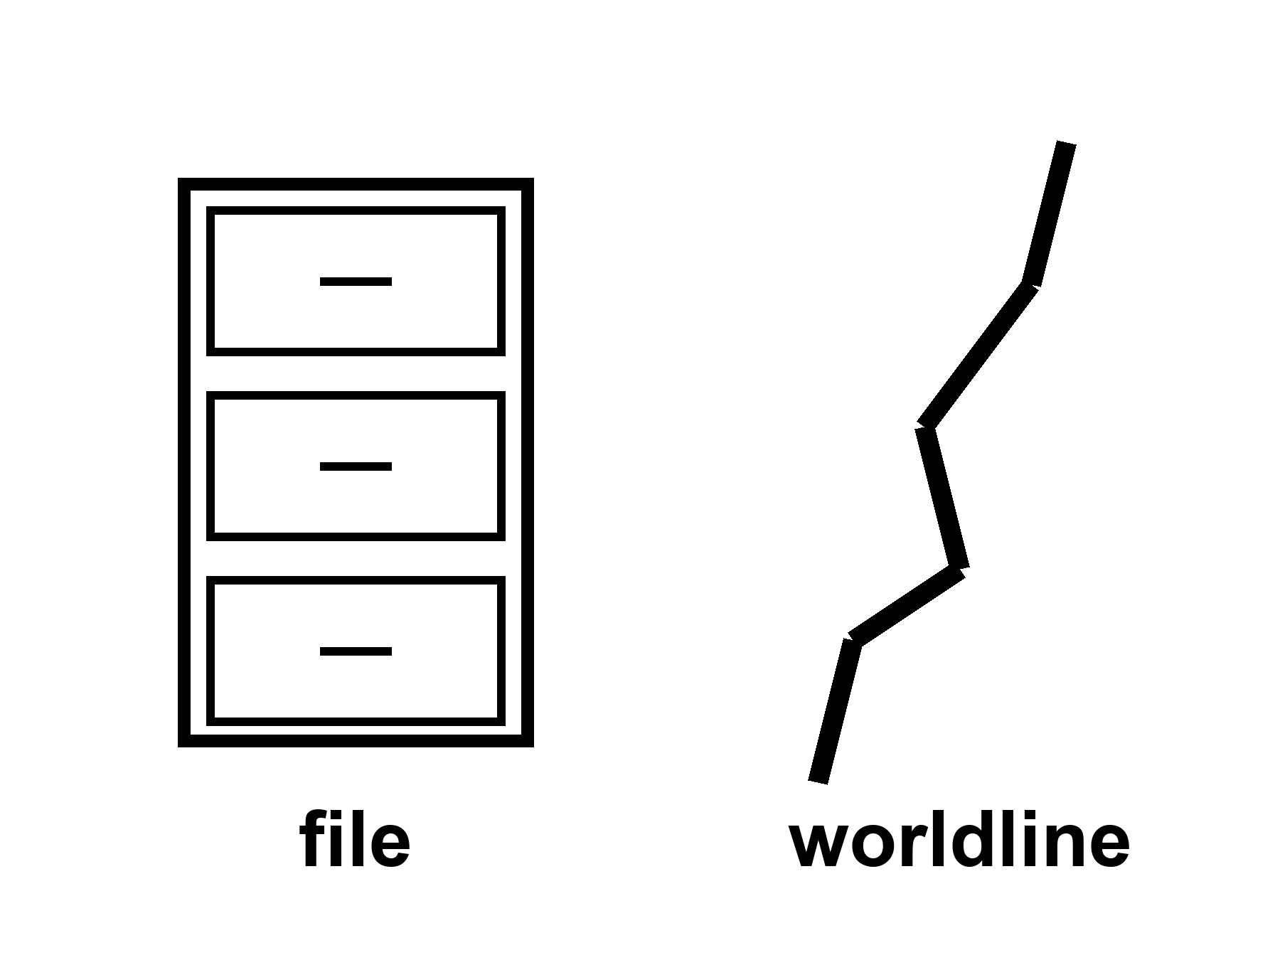
Figure 15. One thread; a box beside it labeled file. The box is not the thread.
If you have the longer book, you have already been told that branches are not destinations and that a required last mind at the end of time fails the leftover shove. Courtesy: that is all. This kitchen can teach the smaller sentence. A scan of a brain, if we had one fine enough — we do not — would be a map. A map is not a walk. Running the map on a substrate that is not the meat would be, at best, a second person who thinks they remember your Tuesdays. The first person would still be in the meat, aging, or dead. Travel did not happen. A photocopy of a letter does not move the sender.
The carrot loves the file. The file looks like an off-switch for death and a spare tank for the mind and a 10,000-year catalog all at once. It is three colds in a trench coat. Death is not an engineering problem with a single port. The mind is not ninety percent waiting to be ported. The catalog is not a method.
What is warm, and should be kept: prostheses, a chip that returns a lost function, a closed-loop stimulator that quiets a tremor, a cochlear implant that is a tool with scars. Local. Chapter 4’s word. A restoration is not an upload. A restoration is a hearing aid with a worse invoice and a better miracle-story. Take the restoration if the Tuesday votes for it. Put the forever-mind down.
Omega-ish stories — a last computation, a required immortality of information, a universe that must end as a mind — stay cold. They were not selected by the accelerating stretch, and they are not selected by a clinic. Anthroposophy and a craftsman cosmos are a different game. This book does not play them.
Incompleteness, if you need a wall: a formal system cannot be its own finished proof. A map of a mind is not obliged to be the mind. That is enough. No sermon from a named book. No helium in a footnote.
She will not be uploaded. The sentence is a kindness. The capsule may keep a joint useful. The radio will stay late. The basil will still need a number. A file of her would be a file. The pH log is already a file, and it is not her. She hits the airlock. The seal is a body fact. Bodies end. The ending is not a failure of a port. It is the size of a worldline.
Appendix A15 writes copy-versus-travel, restoration-versus-upload, and why a required forever-mind stays cold. Here, keep the thread and the box. The box is not the thread.

16. The Honest Body
Cash the recognitions.
Lifespan is not healthspan. That split is hot. The product, if you want one, is mornings you would vote to repeat, not a longer evening in a chair.
Aging is many clocks, not one fuse. Hot-to-warm. A shout at one clock does not reset the kitchen.
Gene fixes are local. Sickle-cell-class wins are hot. A fountain is cold. 150, 200, 1,000 as a scheduled product: cold. Modest further healthy years this century in rich-country medicine: warm. Everyone shares them: cold.
We already use the organ. The ten-percent sentence is false. Hot as a correction. Plasticity is real and expensive. A spare-tank unlock is cold.
The carrot has no off-switch. A longer life is more calendar for the same loop. Look first before you call that an upgrade. Do not overwrite a childhood because a slide said enhancement.
The last fifty years were real and not a straight line. Progress is more often an S. Ten thousand years is not ×200. The limit is often a meeting, a ledger, a famine, a front. A file is not a worldline. Forever-mind stays cold.
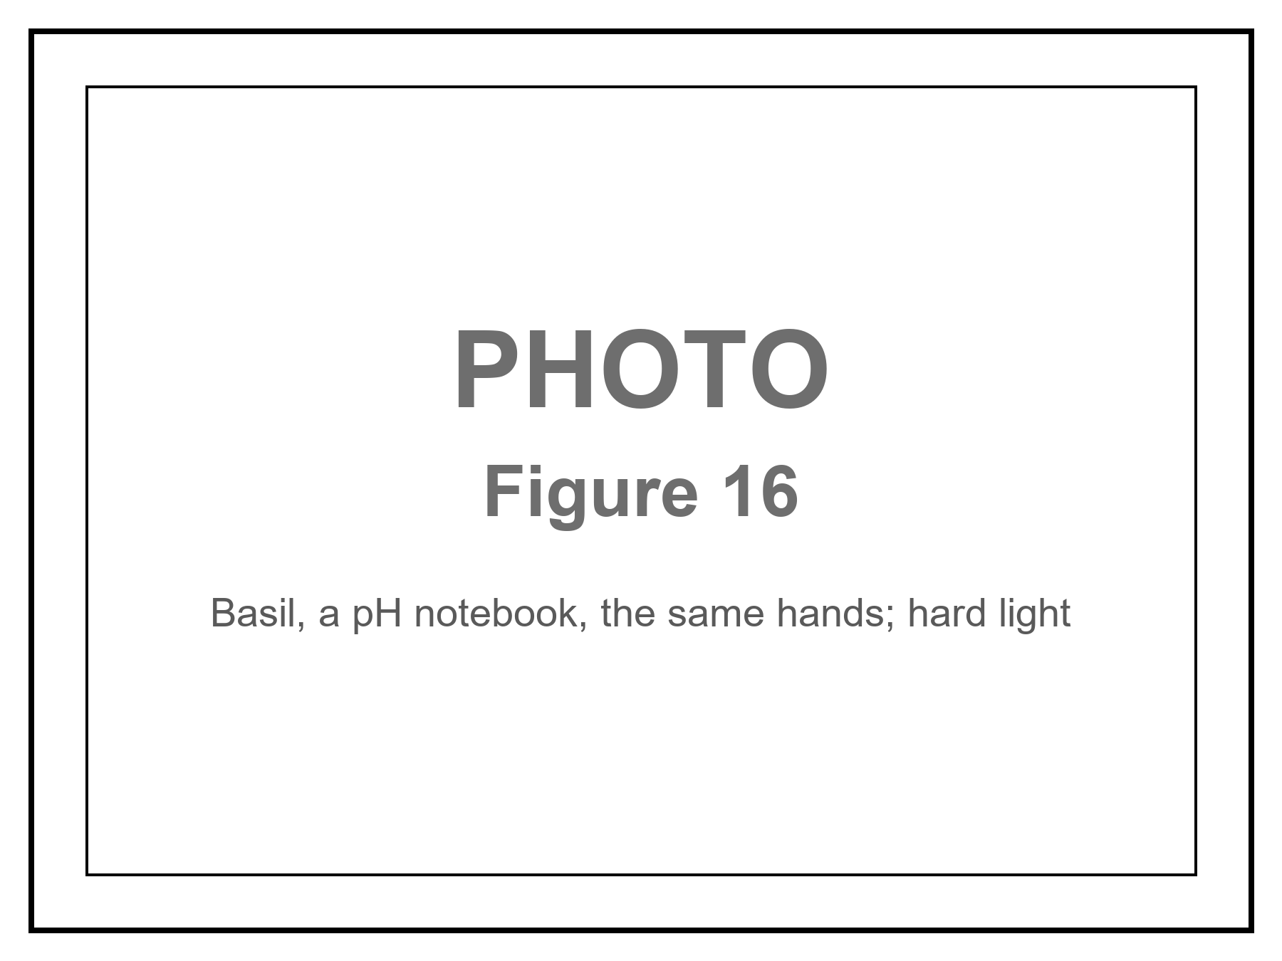
Figure 16. Hands, a basil tray, a blister, a pH log. The caption: do not wait for helium.
She names the basil. Sentiment does not get to vote. The capsule may buy her a useful season. It will not buy her helium, and it will not unlock a brain she was not already using. She is not a different species. Her hands still age. The dirt still has a chemistry. The chemistry can be bullied. That was always the whole trick.
Hit the airlock. Log the pH. Take the local win. Put the sermon down. The radio will be late. The delay is light. Light does not care. You do not have to care about helium. You have to care about the Tuesday.
If you wanted a thousand-year ape, you should leave with a colder, better want: more mornings that are worth logging. If you wanted a spare ninety percent, you should leave with the organ you were already using, plus a notebook, plus a night’s sleep, plus someone like Rohan who already knows the pump. If you wanted year 12,000’s kitchen, you should leave with the invoices that will still be due, and without a catalog we cannot name.
A destinations book, if you want it, will keep her seal and refuse a downtown. A loaf book, if you want it, already refused a cosmic now and a required last mind. You do not need them. You can stop here. The hands will still be the hands tomorrow.
A last inventory, spoken in the tin so it has dirt on it.
The capsule is late. The label is still optimistic. The joint is a two today and not an eight. That is a local win. She would vote for this Tuesday: the airlock, the basil, Rohan’s bad joke about the pump, a radio that carries a slipped date and does not get to vote. She would not vote for a longer evening in which the pulse continues and the hands will not open a jar. She does not have a spare mind in the cupboard. She has a notebook. She does not have a file that is her. She has a log that is not her. She does not have year 12,000. She has a film that will go alkaline if she gets sentimental.
That is the honest body. It is not small. It is the only size that has ever reliably been for sale.
Do not wait for helium.

APPENDIX — The Scientific Detail

How to Read These Notes
Each note An twins popular chapter n. Units are SI unless stated. Brand names rot; classes of win do not.
String theory, if named: cannot currently be tested. It is not needed for a joint or a genome.

A0 / A1. A Local Dose Is Not a Species Change
Hot / warm / cold as in Chapter 1. A local edit that reaches a clinic can warm. A fountain does not warm because the local edit did.
Local: this tissue, this season, this invoice. A joint drug, a lubricant, a replacement, an anti-inflammatory: tools. They do not rewind telomeres, immune grudges, or a hippocampus.

A2. Life Expectancy, HALE, and the Supercentenarian Tail
(1) Life expectancy at birth is a period summary of death rates, not a promise to a baby. HALE (healthy life expectancy) subtracts years lived with disability, weighted.
Rich-country LE: women often low-to-mid 80s; men a little lower (Japan, Switzerland, Spain, Australia, Italy, Nordics as a band). United States: high 70s in recent ledgers after a dip — a rich-country warning, not a law of biology.
Jeanne Calment: documented ~122 years (1875–1997). Tail, not a mean, not a protocol. Supercentenarians (≥110) are a validation sport, not a clinic.
Maximum observed lifespan has not sprinted the way averages did. Averages moved largely by not losing the young.
Modest further healthy years this century in rich-country medicine: warm. Everyone shares them: cold.

A3. Hallmarks, Hayflick, and Why One Switch Is Not on the Counter
(3) Hayflick range: many human cell types in a dish divide about 40–60 times, then senesce. Mechanism accent: telomere attrition and a DNA-damage alarm. Mice are not women (longer telomeres, shorter lives).
Hallmarks (López-Otín class lists grew from 9 toward 12): genomic instability, telomere attrition, epigenetic drift, loss of proteostasis, deregulated nutrient sensing, mitochondrial dysfunction, senescence, stem-cell exhaustion, altered intercellular communication, disabled autophagy, chronic inflammation, dysbiosis. A list of twelve is a confession that there is not one fuse.
Aging clocks (epigenetic predictors): hot as correlates, warm as mechanism, cold as a rewind of a person to twenty.

A4. CRISPR-Class Edits: This Gene, This Tissue, This Invoice
(4) Local fix: this gene, this tissue, this person, this price, this entry-fee harm.
Sickle-cell-class: a single-letter hemoglobin problem; autologous edit of blood-forming stem cells; often wake fetal hemoglobin by breaking a BCL11A-class switch rather than correcting the letter; conditioning chemotherapy; hospital stay; present prices in the low millions of dollars per person. Exagamglogene-class CRISPR and lentiviral gene-addition cousins: hot as a class (2023-era clinic facts). Not a fountain.
Delivery is most of the problem (AAV, lentivirus, lipid nanoparticles; liver ≠ brain). Immune memory can forbid a second truck. Germline editing is a front (A12), not a gadget.

A5. Cancer, Plumbing, Neurodegeneration: Many Doors
Cancer: plural careers of a cell; prevention still the cheap hot work; some five-year survivals moved, others barely. A longer ape is a longer mutational exposure unless you invent a surveillance state inside every tissue (cold as a product).
Atherosclerosis: lipids, pressure, smoke, shear, clot. Pills, stents, bypasses: incremental, hot as classes. Not a rewind of seventy years of dinner.
Neurodegeneration: Alzheimer’s, Parkinson’s, vascular, Lewy, frontotemporal, ordinary narrowing — plural. A plaque-clearing drug with a modest delay is a local, argued result, not a resurrection.
150 / 200 / 1,000 years as scheduled products: cold.

A6. The Ten-Percent Sentence, Lesions, and the Energy Bill
(2) Brain ≈ 2% of body mass, ≈ 20% of resting metabolic rate. A miser mesh does not keep a 90% dark warehouse at that wattage.
The “10%” sentence has no volumetric survey behind it. James-style effort talk mutated into a floor plan. Lesion maps (stroke, hippocampus, cerebellum, white-matter cuts) are a cartography of on duty. Hemispherectomy and slow tumors show development and time can reassign jobs — not that ninety percent was decorative.
False; correction hot. Do not dress as a future unlock.

A7. Tools with Invoices: Sleep, Hearing, Stimulants, Implants
Sleep: consolidation, clearance, a night shift; fragment it and cognition pays. Hearing: loss is a dementia-risk factor in ledgers; aids are tools. Stimulants: small, messy, known invoices (sleep, appetite, habit). Education: the oldest cognitive tech.
Implants that return a lost function (cochlear, tremor loops): local restorations with scars. Unlocking a spare ninety percent: cold.

A8. Wanting, Liking, and Mismatch with More Calendar
Wanting (seek, cue, go) ≠ liking (completion stamp). Supernormal cues outbid the thing (the fake egg). A longer healthspan is more calendar for the same Pleistocene loop, not a wise king as a default.
Book 1 Chapter 30 taught the loop in another kitchen (shuffle, fake). One courtesy. The argument here does not need a second origin.

A9. Vaccines, Packets, Sequence, Compute — and Named Walls
Last ~50 years, uneven and real: childhood-disease rooms closed in lucky kitchens; mRNA as a platform stair; sequencing from ~10⁹-dollar draft to clinic-scale invoices; packets and error-corrected links; cheap compute.
Walls: energy, materials, attention, war, institutions. A stair is not a ruler.

A10. Logistic Growth, Moore’s Bend, Sequencing’s Collapse
(6) Logistic / S-curve: slow start, steep middle, wall as the room fills.
(5) Sequencing cost per human-scale genome dropped by many orders of magnitude from the first draft; interpretation and action did not drop with the same slope.
Moore’s packing had a drunk middle and a bend (watts, lithography as cathedral, parallelism and specialist silicon as the continuation). Exponential is often a middle photographed without shoulders.

A11. Why 10,000 / 50 Is Arithmetic, Not a Method
(7) 10,000 / 50 = 200 is a ratio of years. It is not a physical method and fails in the rearview (any prior fifty, multiplied, prints the wrong furniture).
No gadget catalog for year 12,000. Honest remainder: energy, heat, coordination, many clocks, losable knowledge.

A12. Meetings, Ledgers, Famines, Fronts
A transistor does not vaccinate a neighborhood or keep a grid up. Institutions store methods; they fail; knowledge dies in fires and fronts. Famine is energy and coordination with a body count.
Germline “enhancement” is a political and ethical front, not a SKU. Look first: do not overwrite a childhood because a slide said the year 12,000 would thank you.

A13. Trials, Harm, and Who Pays for the Local Fix
Trials are how a kitchen refuses a founder’s word; they include no as an outcome. Conditioning, cytokine storms, vessel risk: entry fees, not fine print.
Price-as-delivery: a low-millions local fix is a ministry-or-insurer object. Rich-country healthspan gains warm; universal share cold.

A14. Plasticity Is Real and Expensive
Sensitive periods make children cheaper to reroute than adults. Stroke recovery is overtime, not a hidden room. Practice thickens a map and eats mornings. Tools and other people are part of the method.
Adjusting ≠ spare capacity.

A15. A File Is Not a Worldline
A map of a brain is not a walk. A run of the map is, at best, a second person. The first person remains in the meat or is dead. Travel did not happen.
Restorative chips: local, warm-to-hot as tools with scars. Uploads / forever-mind / required Omega-ish last computation: cold. Book 1 already broke the required last mind on the shove; this note does not reopen the leftover glow.

A16. Inventory of Claims, by Temperature
Hot: lifespan ≠ healthspan; hands age; 10% brain sentence is false; sickle-cell-class local wins exist; last ~50 years saw real uneven gains; most near-term humans are not a different species because of a capsule.
Warm: many aging clocks (map real, unified switch not on the counter); modest further healthy years this century in rich-country medicine if institutions hold; S-curves as a pattern; plasticity as expensive reroute; restorative devices.
Cold: fountain / 150–200–1000 as scheduled products; everyone shares the gains by default; spare-tank unlock; last 50 × 200 = year 12,000’s kitchen; a gadget catalog for that year; progress guaranteed if we wait; uploads as travel; required forever-mind.

Equations at a Glance
# | Relation | Role
(1) | LE vs HALE | Two pots
(2) | ~2% mass, ~20% resting energy | Brain bill
(3) | Hayflick ~40–60 | Dish limit, not a mystic fuse
(4) | This gene, this tissue, this invoice | Local fix
(5) | Sequencing $ drop | Stair, not wisdom
(6) | Logistic / S | Shape of a gain
(7) | 10,000/50 = 200 | Arithmetic, not physics
(8) | Inventory in A16 | Temperatures

Further Reading (tiered)
Start here: WHO HALE notes; a hallmarks-of-aging review; a sickle-cell gene-therapy class paper (not a brand halo); any honest history of antibiotics’ S-curve.
Avoid as medicine: a 1,000-year roadmap; the 10% sentence as a future; last-fifty × 200 as a method.

Glossary
Healthspan. Years you would vote to repeat.
Local fix. This gene, this tissue, this bill.
S-curve. Slow, drunk, wall.
Carrot. A seek loop with no off-switch labeled picture only.
File. A map. Not a worldline.

